Java Debugging

Vidyashankar, Vivek & Sankar Ganesh

Table of Contents

1. Basic Information on tools 3

1.1 Tool Information and download sources 3

1.2 JDK (Java Development Kit) downloads 3

1.3 Installing IDE (Integrated Development Environment) 3

2. Simple Java Project (Creating and Debugging) 5

2.1 JRE settings 7

2.2 Eclipse viewing perspective 8

2.3 Adding new package and classes 10

*2.4* Exception Handling 14

2.5 Running the Java Project 16

2.6 Adding Breakpoint in Eclipse 18

2.7 Debugging steps 20

2.8 Variable modifications at run time debugging 22

2.9 Viewing all Breakpoints and Keyboard shortcuts 23

3. Maven installation 24

4. Creating Spring Boot Project (API Development) 25

4.1 Maven project categories 26

4.2 Group & Artifact id and Version 26

4.3 Project Build Path and .m2 repository 27

4.4 Maven Build steps 29

4.4.1 Maven Clean 29

4.4.2 Maven Install 30

5. Maven build issues and debugging 30

5.1 Jars download issues 30

5.2 Folder .m2 deleted 30

5.3 Jars download issues – Repository connect issues 30

5.4 Jars download issues – Repository target issues 31

5.5 Build Failure – Project Maven update 31

6. Running Spring Boot Application 32

6.1 Starting spring boot application 32

6.2 Starting spring boot application in Debug mode. 32

7. Debug Spring Boot Application 33

7.1 API targets request giving 404 33

7..1.1 URL mismatch 33

7.2 Annotations missing 34

7.3 API targets request giving 405 34

7.4 API targets request giving 500 error 35

7.5 API targets request giving 503 error 36

7.6 Dependency Injection issues 36

7.6.1 Auto-Wire issues 36

7.6.2 Auto-Wire issues with duplicate URL mapping 37

7.7 Data saving issues 39

8. Creating a spring batch project and running it 39

8.1 Creating a project and configuring it for batch 39

8.2 Running a spring batch Application 40

8.3 Debugging a spring batch Application 40

9. Spring Tool Suite 41

10. Code with bug for fixes. 43

# Basic Information on tools

## 1.1 Tool Information and download sources

|  |  |  |
| --- | --- | --- |
|  | Source | Comments |
| Eclipse | <https://www.eclipse.org/downloads/> | When your project is any simple Java program, J2EE, SpringBoot based API, use Eclipse IDE. |
| Spring Boot | <https://spring.io/tools> | When your project is SpringBoot based API development, use the SpringTool Suite from this link.  This is a customized tool extended from Eclipse mentioned in above row. |
| Maven | <https://maven.apache.org/download.cgi> | This is software project management tool, from where jars dependencies are configured and build is given. |

**Table 1** : Tools and download sources

## JDK (Java Development Kit) downloads

Download the JDK latest version from the link: <http://www.oracle.com/technetwork/java/javase/downloads/index.html>

## Installing IDE (Integrated Development Environment)

Projects are coded on a IDE which is GUI based software which facilitates the development, debugging the code in a structured manner for developers. Eclipse is an open source IDE which is most commonly used.

**Table 1**: Tools and download sources provides the link to download the Eclipse IDE. When Installing Eclipse, always choose “Eclipse IDE for Enterprise Java and Web Developers” to ensure you have everything for Java, J2EE and API Services development.

See the below **Screen shot 1**: Eclipse Installer options

Follow the installation steps as described below.

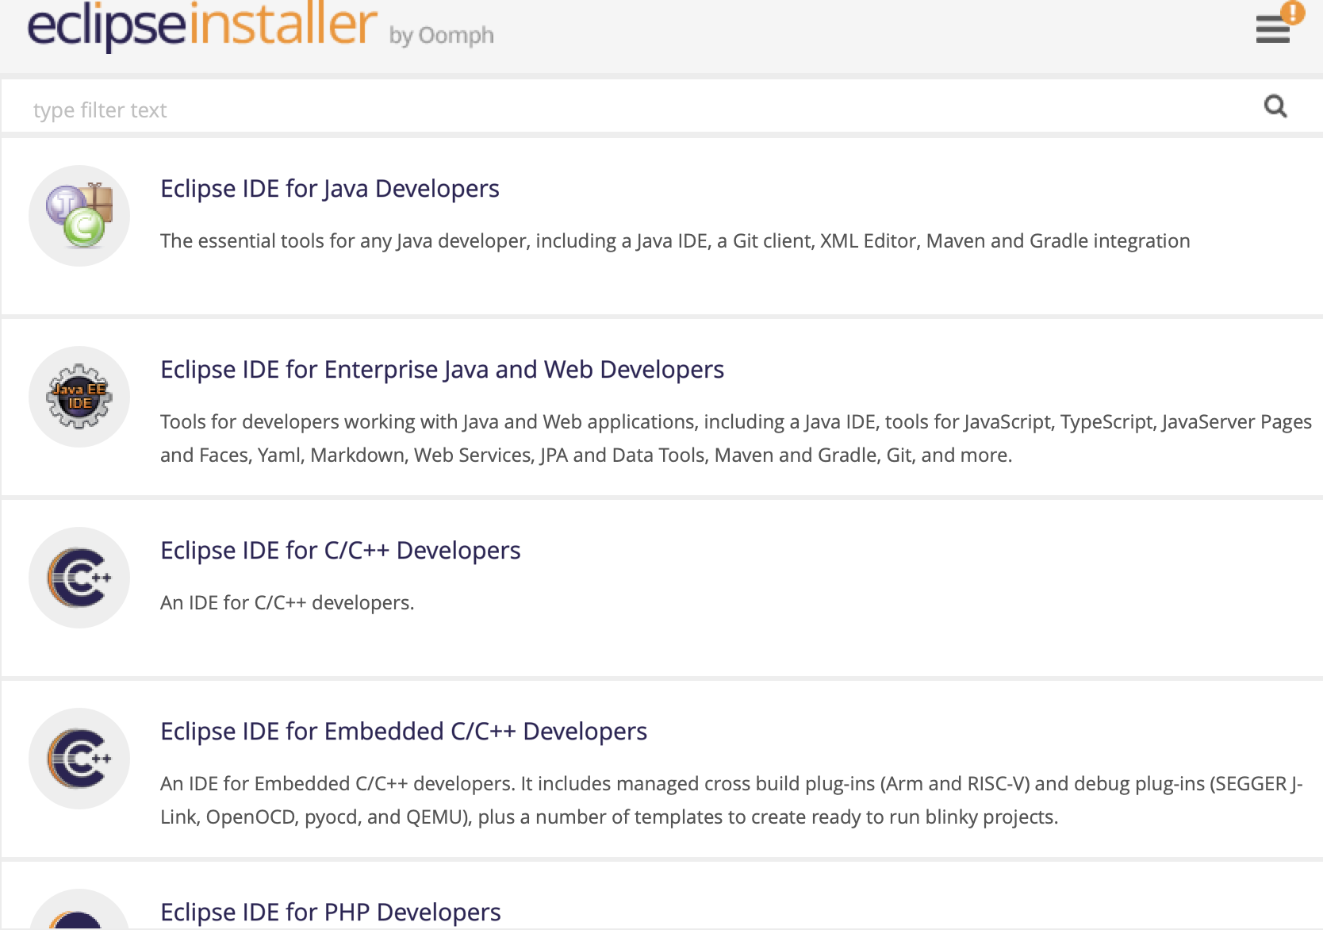

**Screen shot 1**: Eclipse Installer options

As displayed in **Screen Shot 2 :** Open Project Explorer, Eclipse project creation options are provided in Projects Explorer.

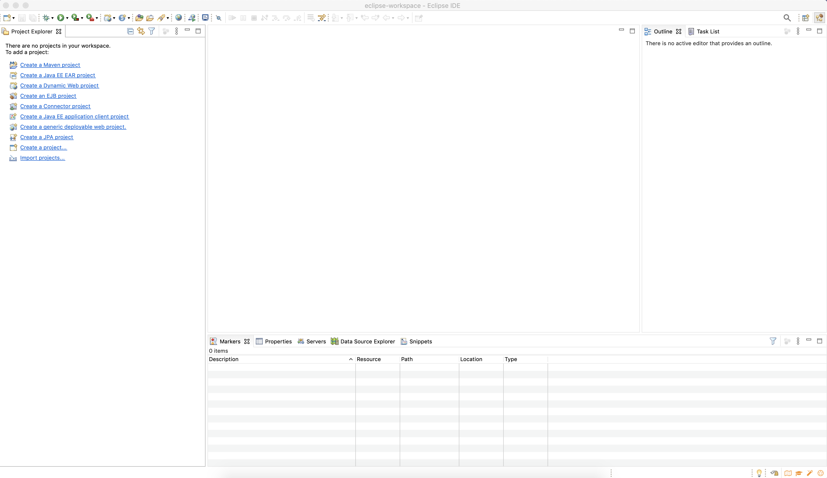

**Screen Shot 2 :** Open Project Explorer

# Simple Java Project (Creating and Debugging)

Create a simple Java project as show in below screen shot to begin with for learning debugging.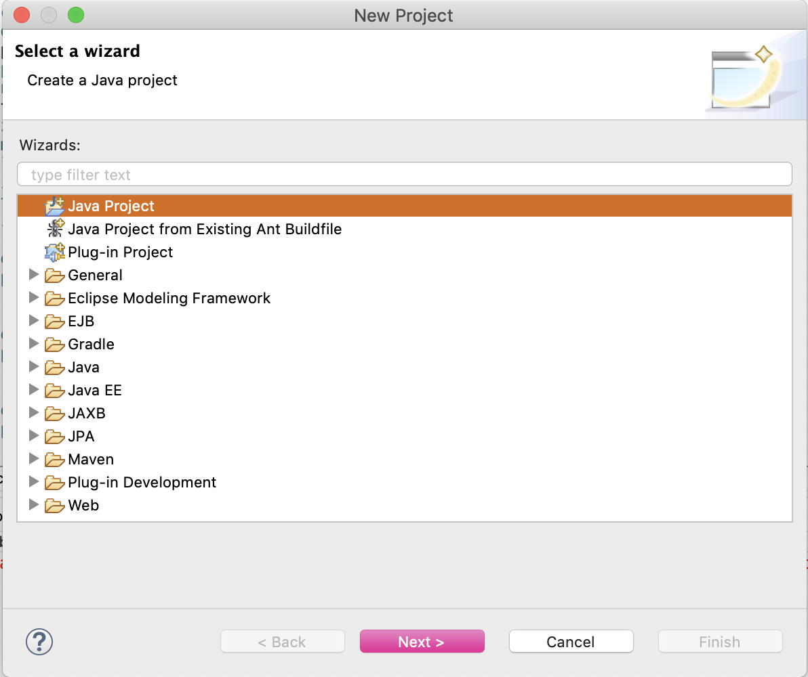

Provide a name to the project relevant to your task.

Select default jre (Java Runtime Environment) version or choose “Configure JRE’s” to select a different installed jre version.

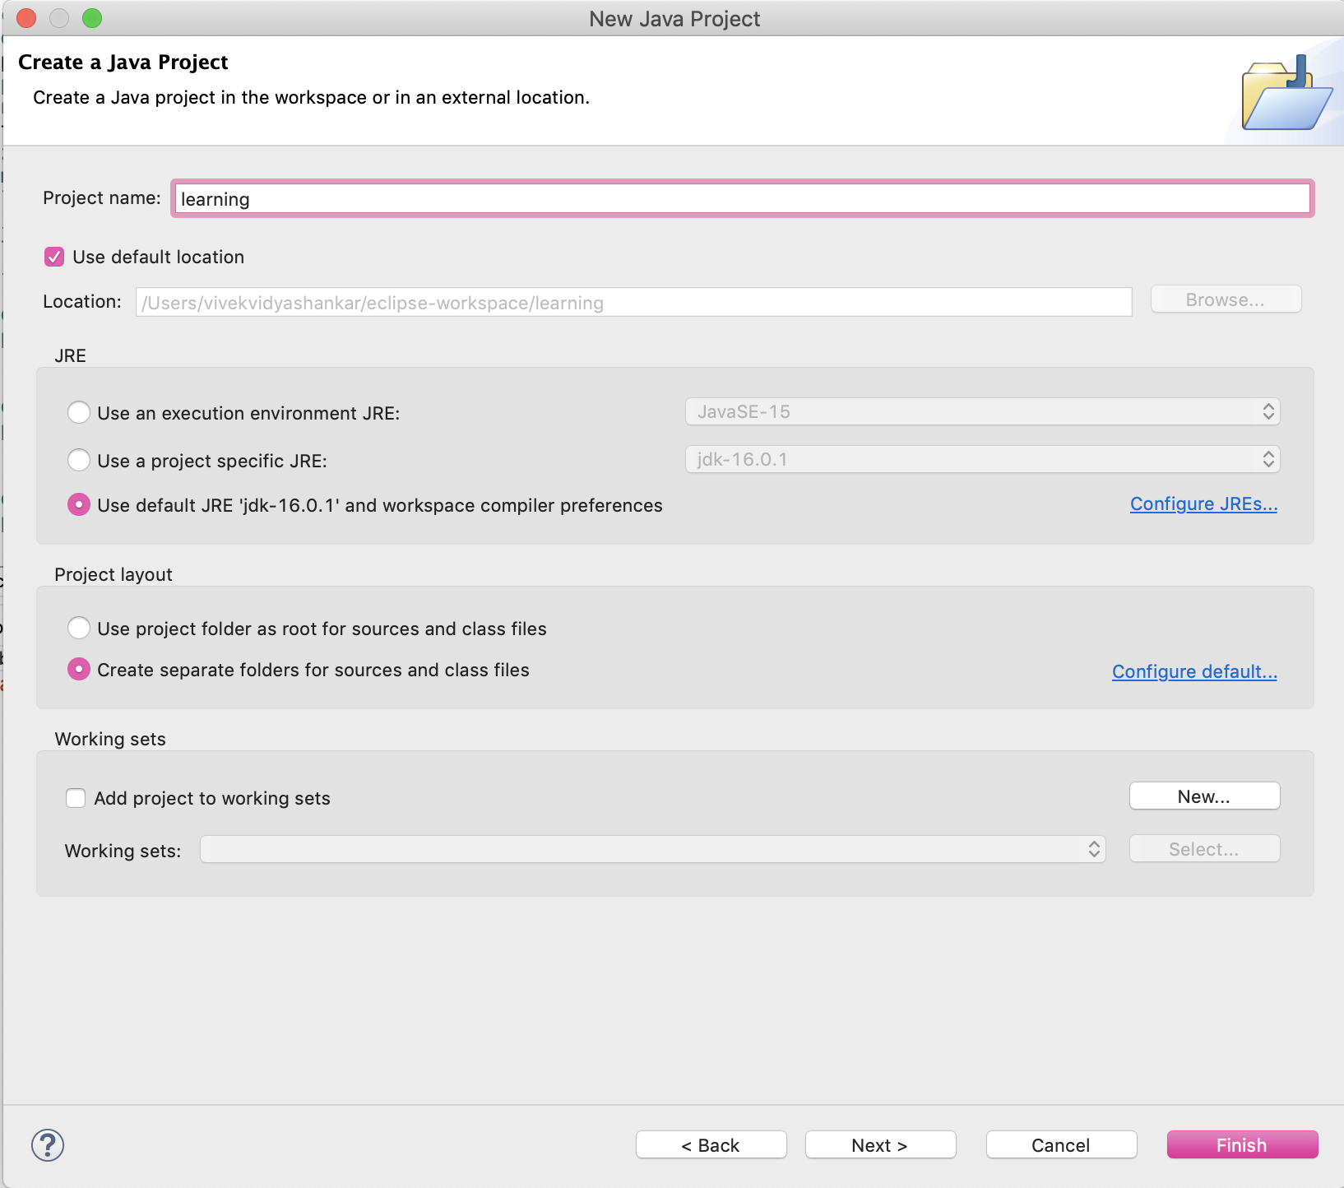

The classes generated can be pushed to output folder to a default folder “bin” or any other folder required. The “bin” folder is recommended.

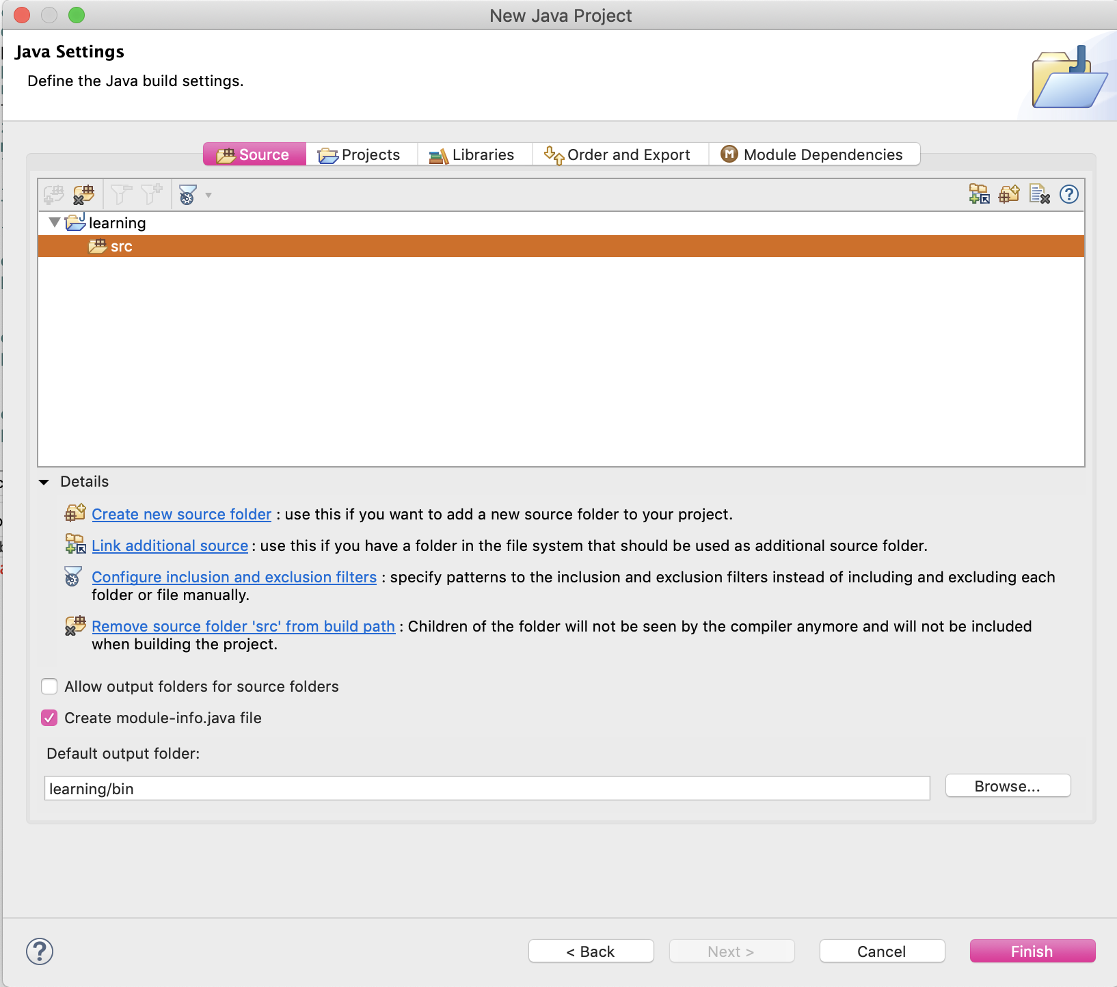

## 2.1 JRE settings

The Libraries tab shows the current selected JRE and options to change the same to a different version

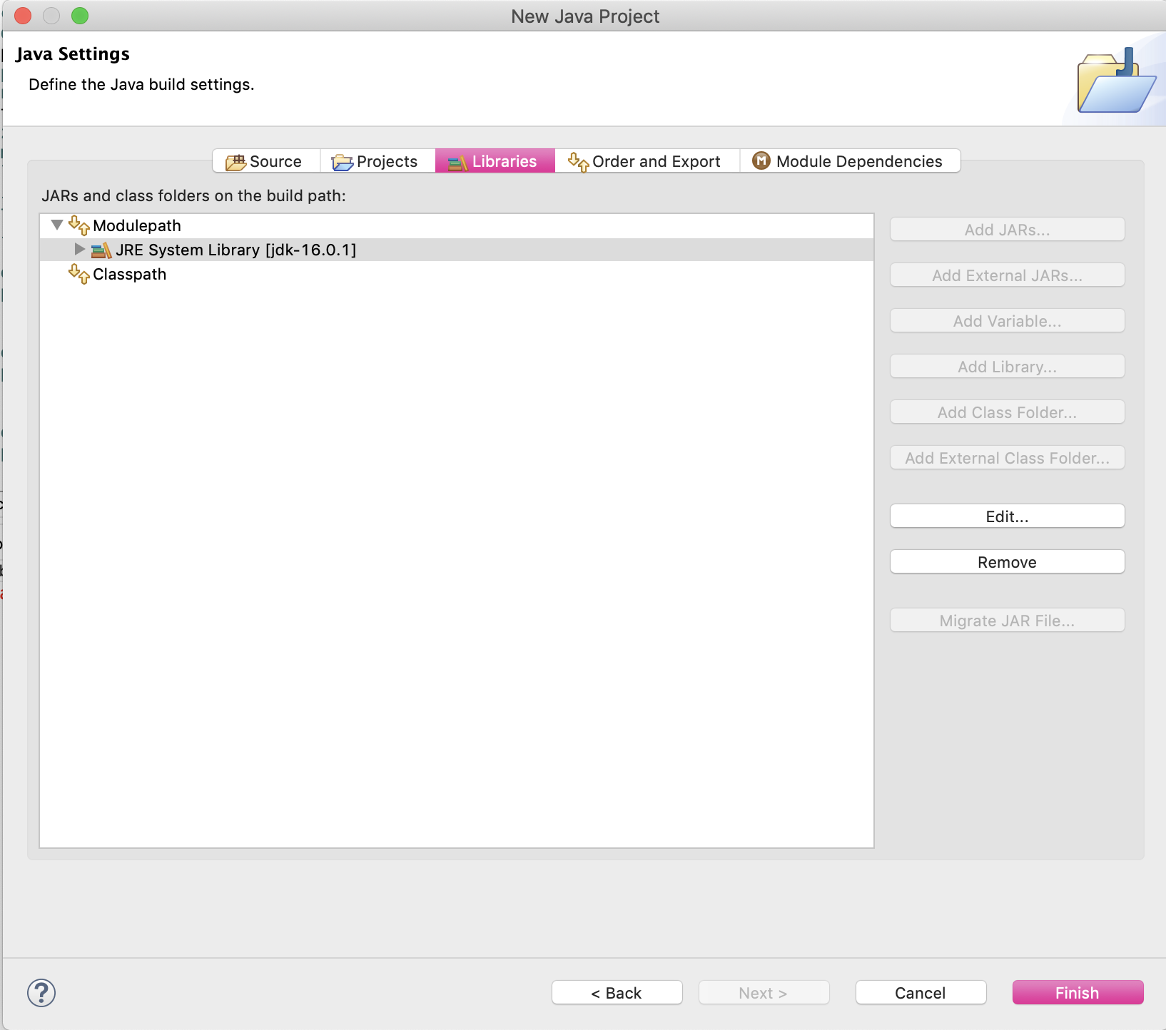

## 2.2 Eclipse viewing perspective

Open the project in perspective called Java Perspective. Remember we have view perspectives for Java, Debug, EE.

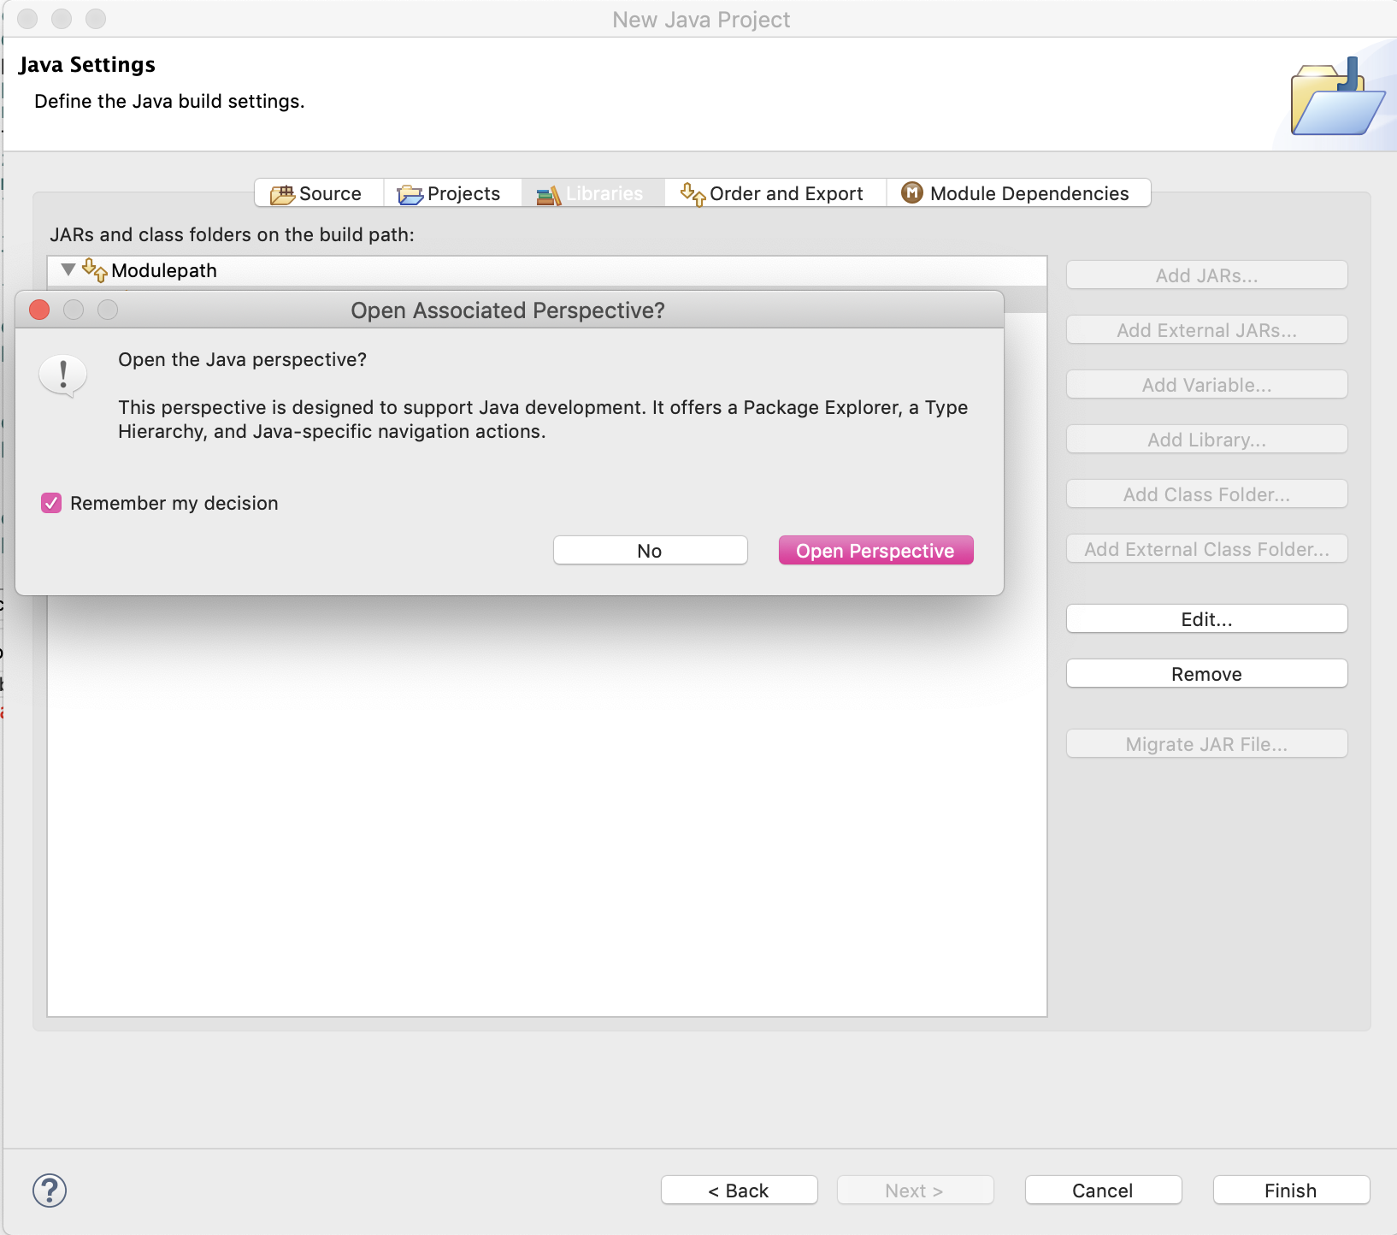

Add new package by clicking on the folder name under which you want to create the same. Here we are creating “lessonone” under “src”.

In a given package folder we can create a new package and / or Java files.

## 2.3 Adding new package and classes

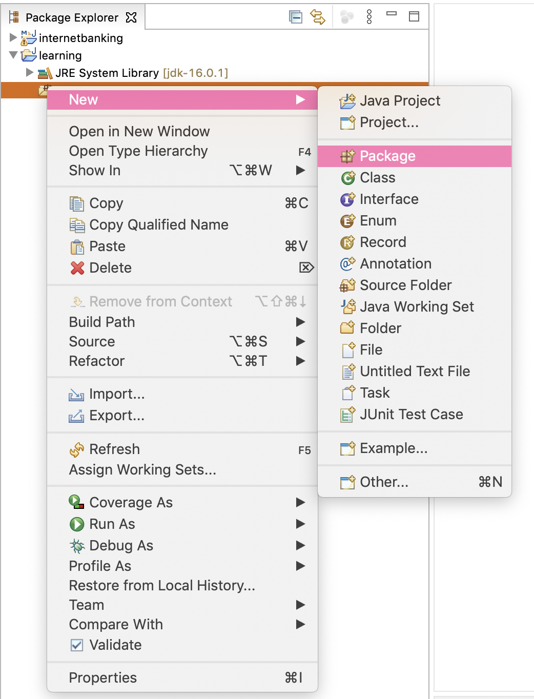



Add a new class under the package by right clicking on the package and choosing the option like below.

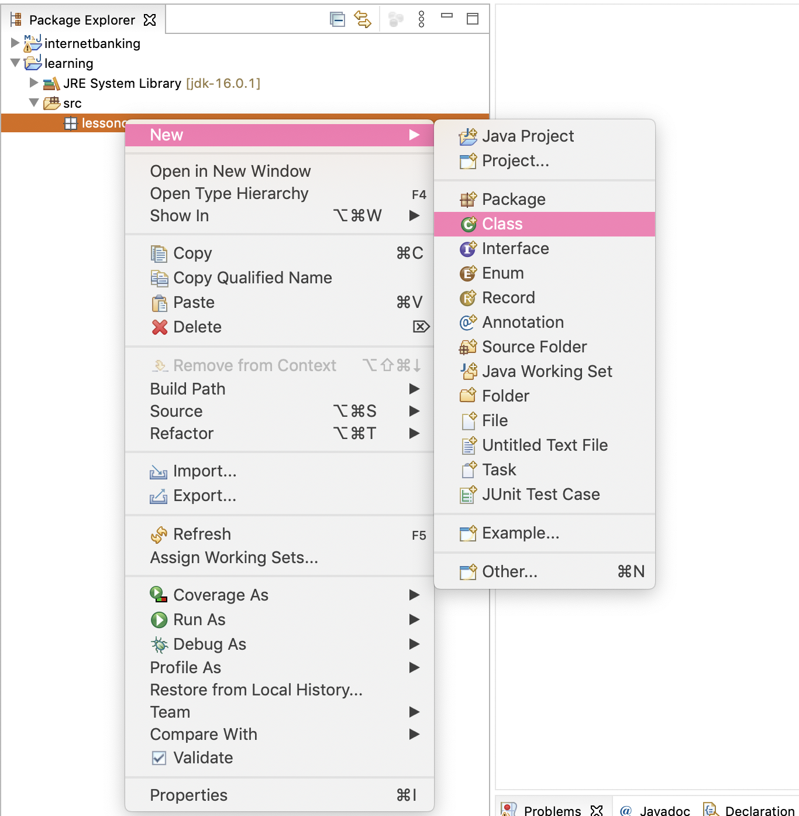

Name the class starting with upper case like Fileaccess. Eclipse supports choosing the modifiers like making class pubic, private, final, abstract.

Note every object by default has super class java.lang.Object, we can mention any interface we would like to implement in “Interfaces” option.

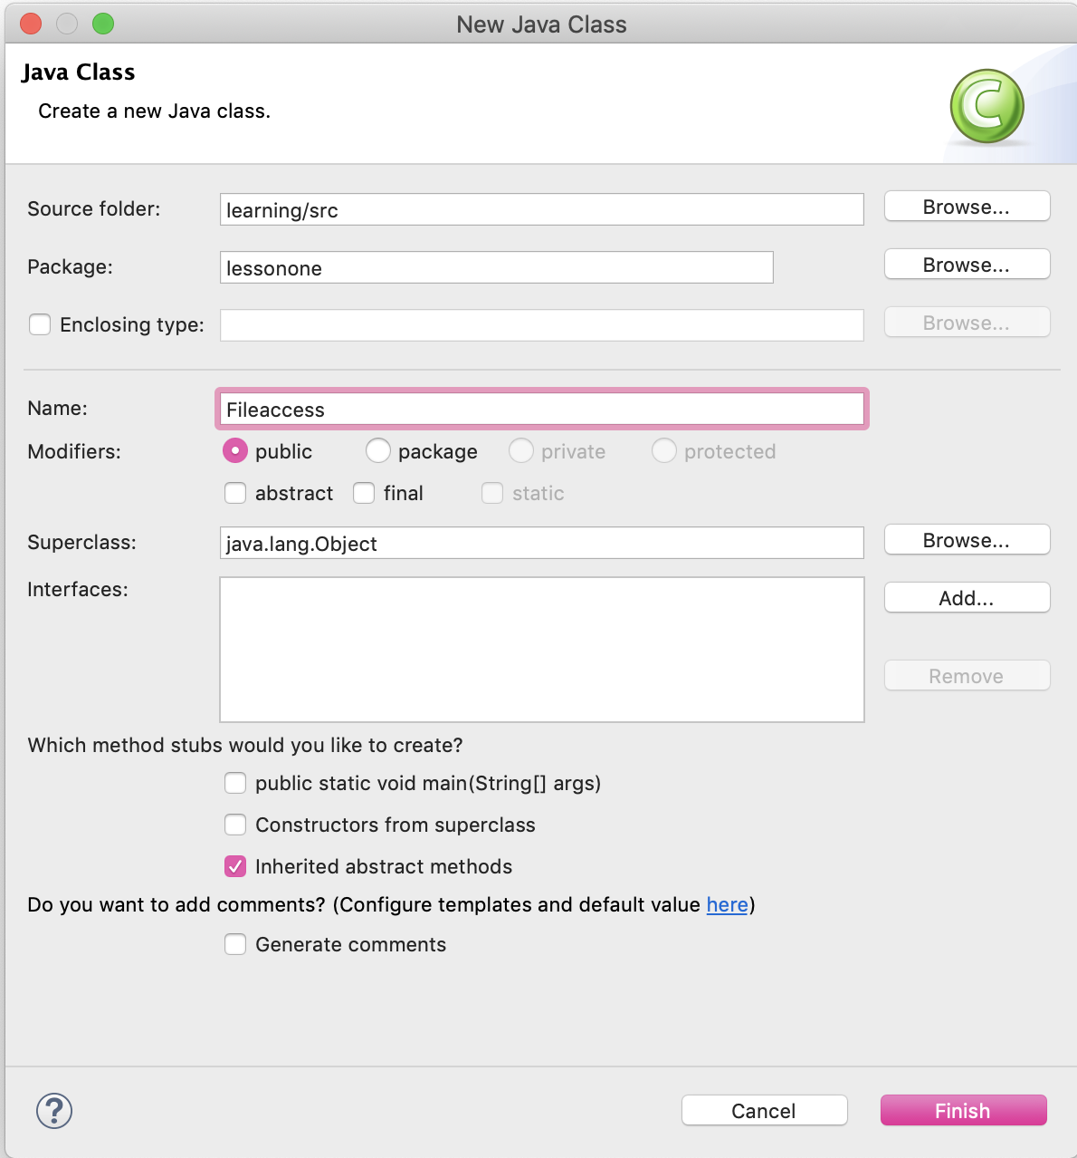

When adding the code, IDE supports the ease of adding the imports. As shown in below screen share when you place cursor on “File” and press “Ctrl + Space” the matching options will be shown which can be selected.

Documentation related to each class appears in IDE, this helps developers to make a right choice.

The red underline indicate the compilation error which must be addressed. The file name in the tab will also show a red x mark indicating issues in compilation.

## 2.4 Exception Handling

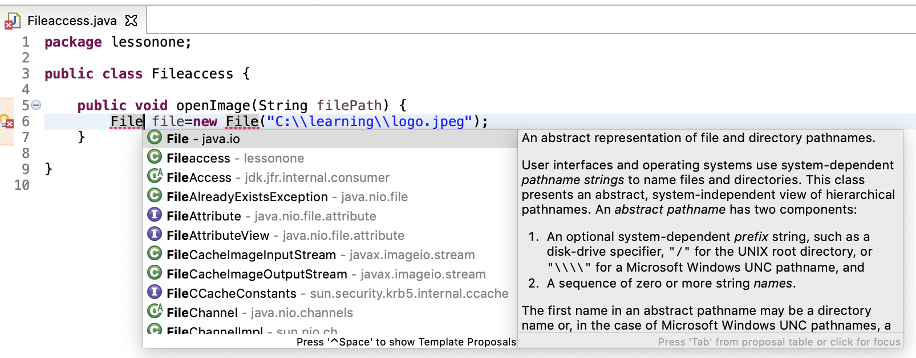

Exception handling is a must and should for all the lines of code.

We can add “throws” with an exception name as shown below or put the code within try-catch block.

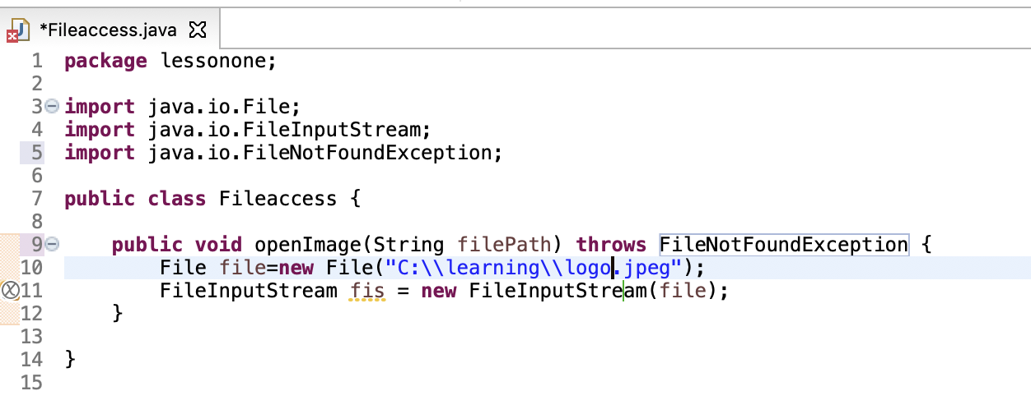

OR

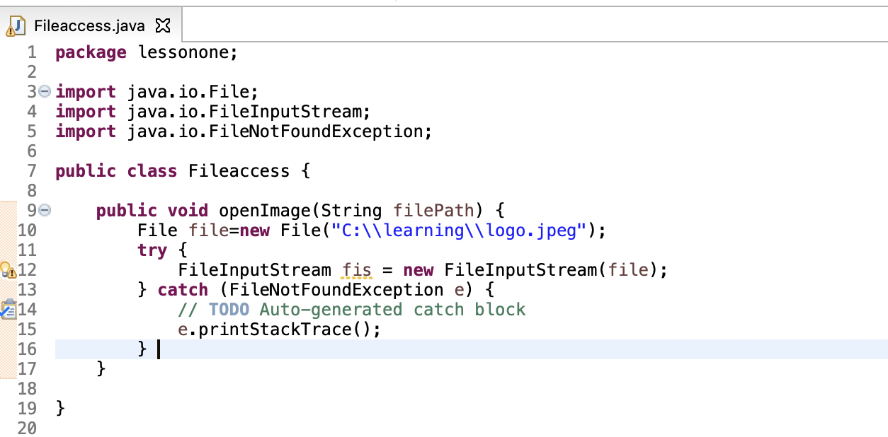

On each variable when you mention a “.” the IDE lists the available pubic methods and variable to access. This must be utilized to speed up the development process.

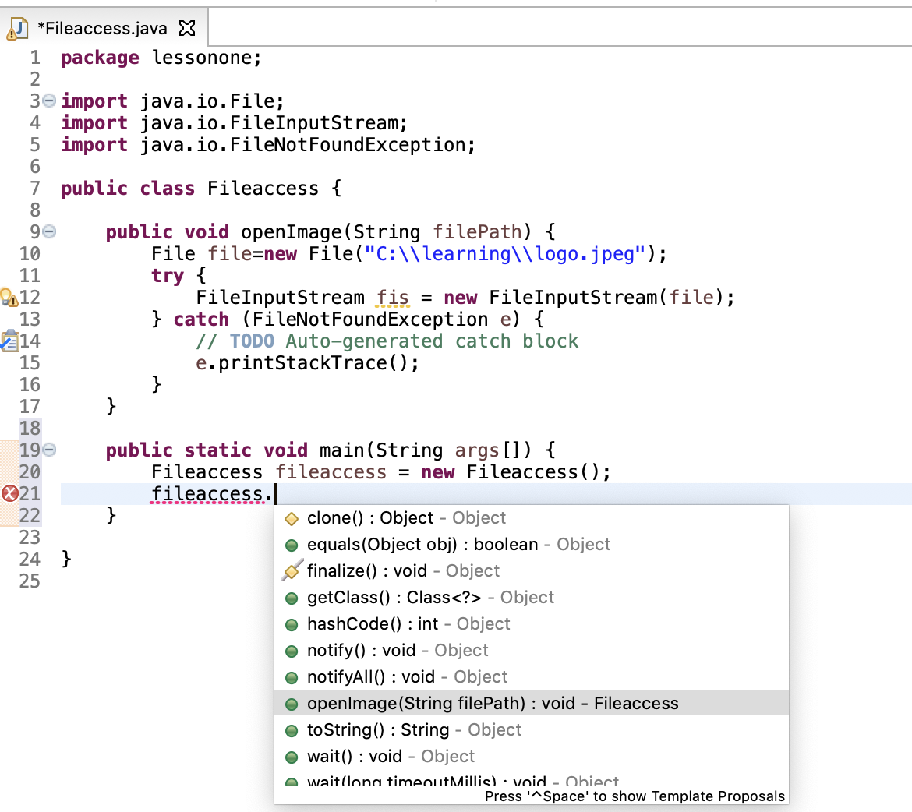

## 2.5 Running the Java Project

To Run the program the Eclipse provides the “Run As” option on the java class which has “public static void main” method.

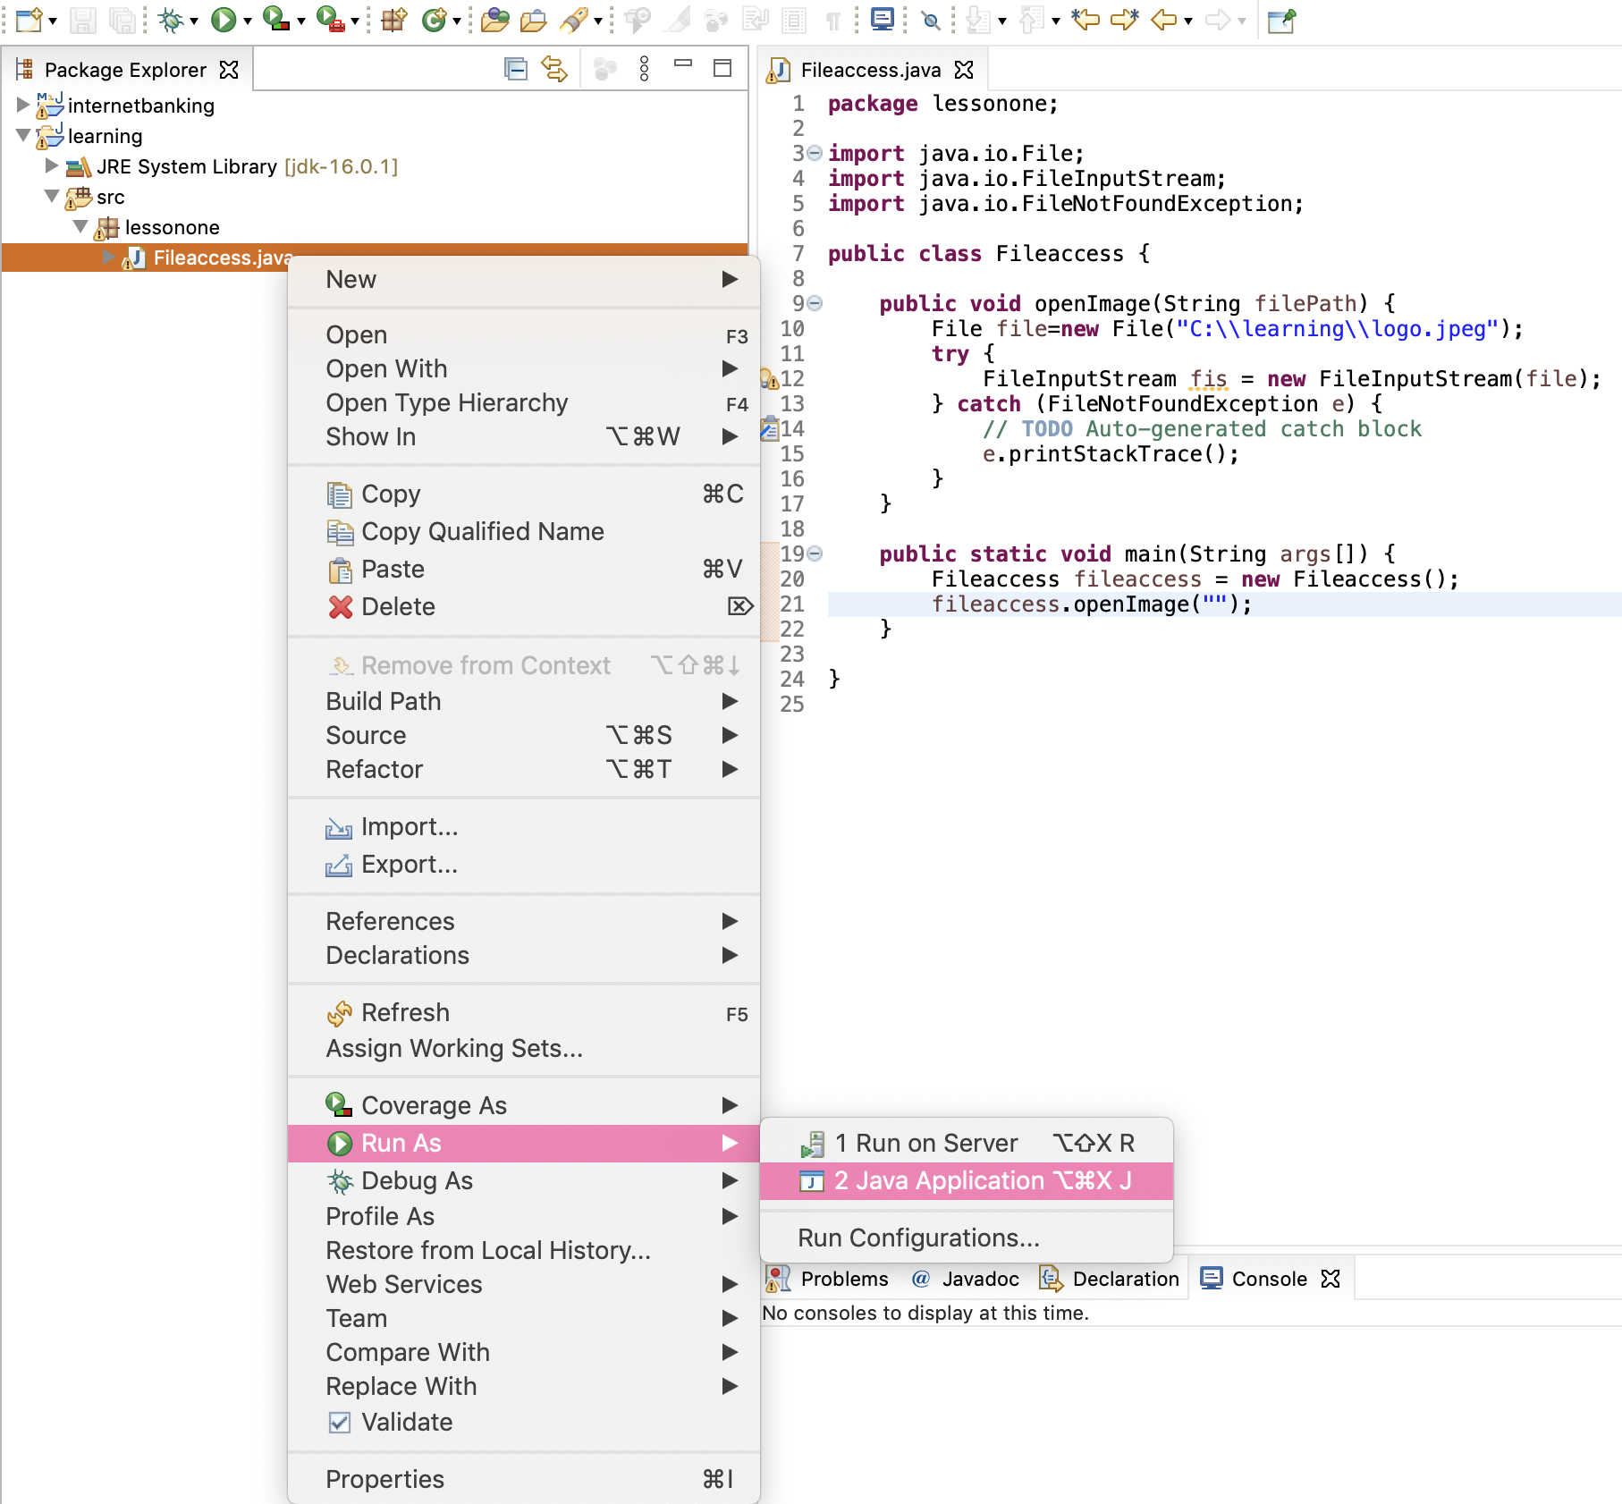

When you see failures related to execution of the class, revisit the JRE selected in the Java Build path on the project properties. Selecting the correct version ensures the possibility of the code execution.

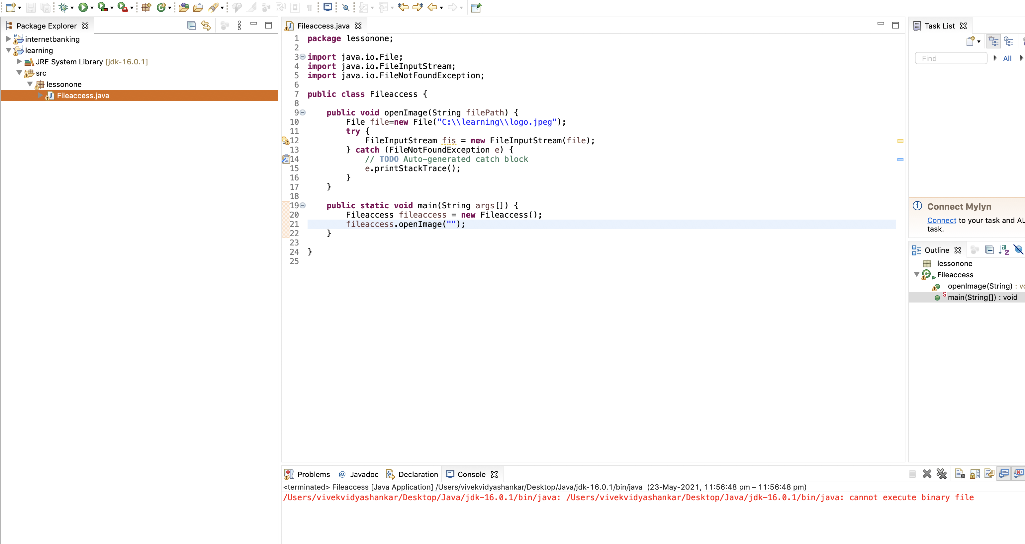

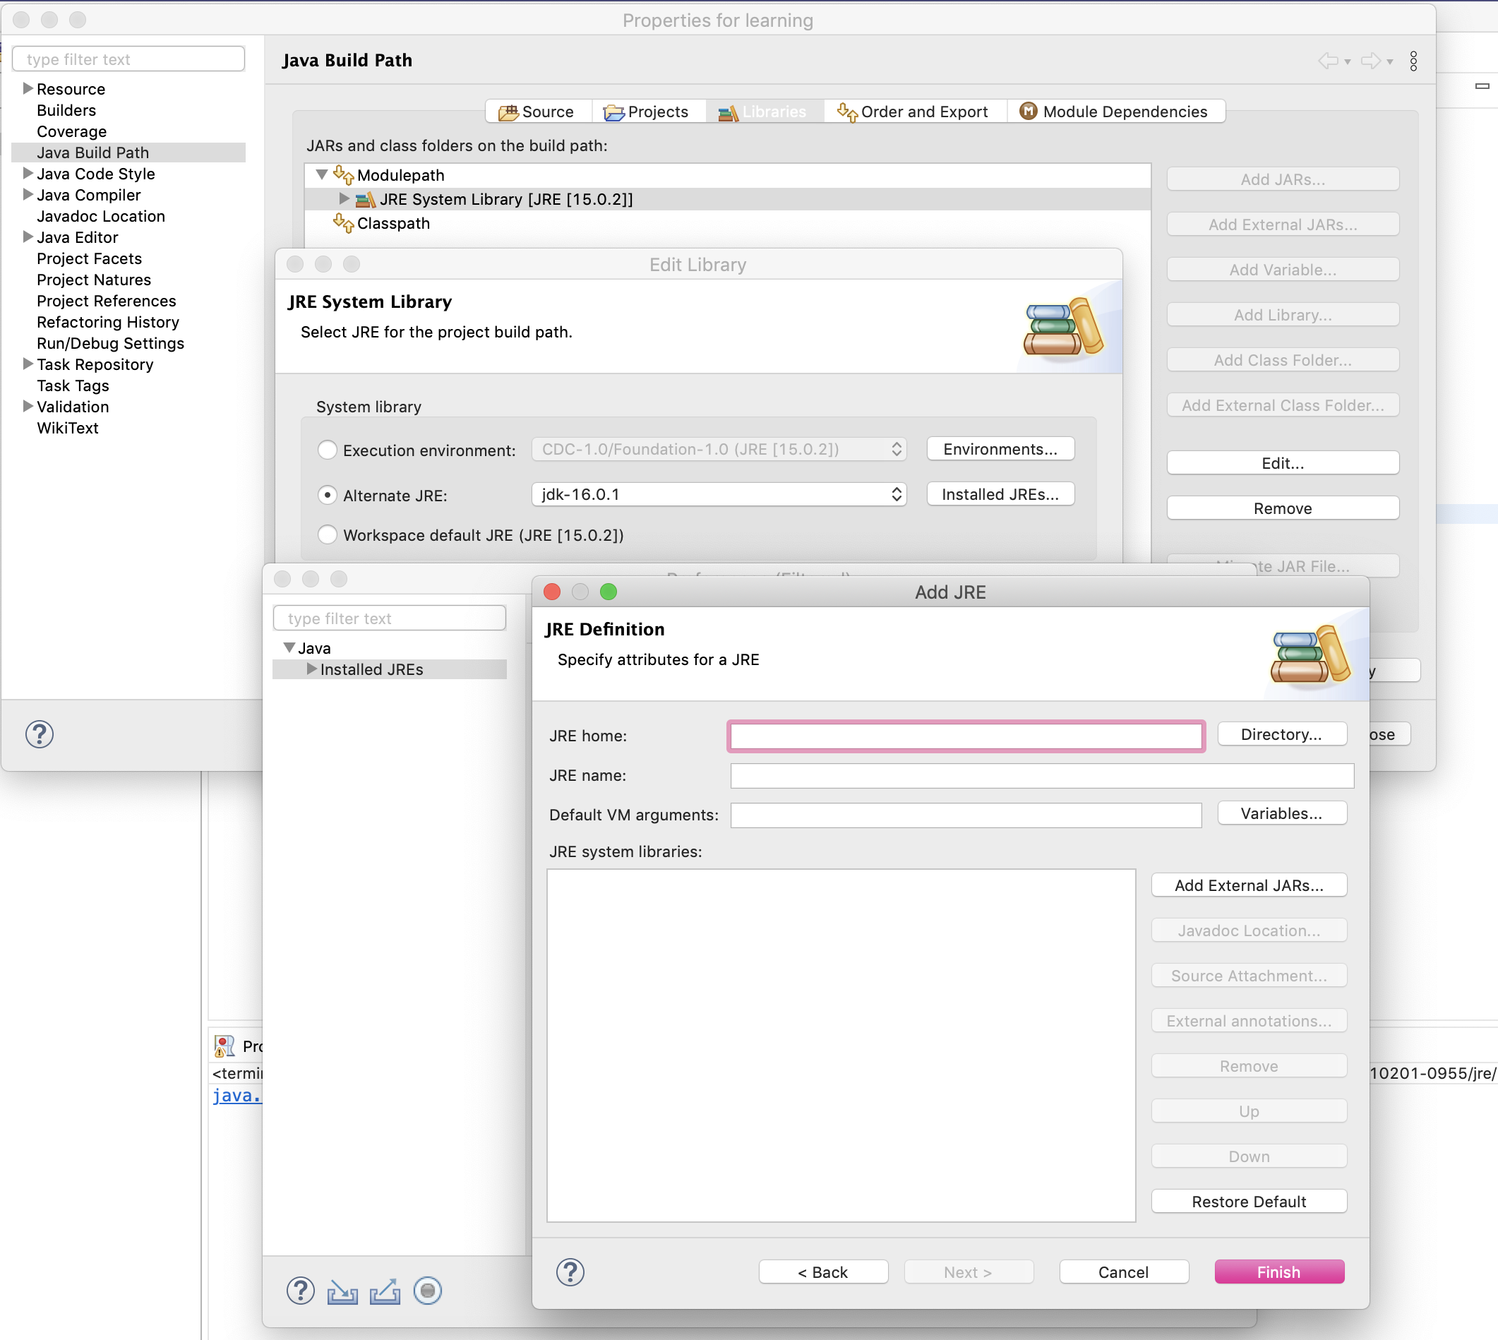

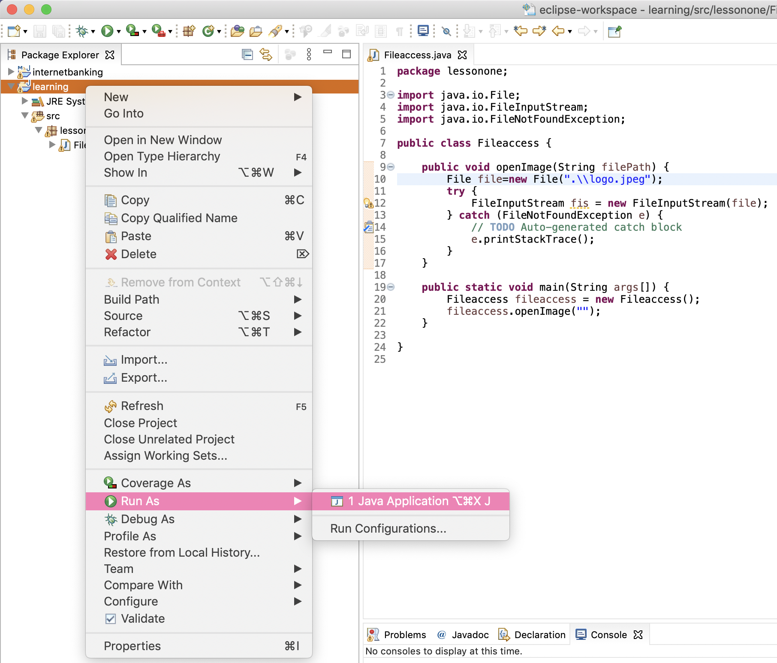

## 2.6 Adding Breakpoint in Eclipse

Break points can be placed by double clicking on the line number where it’s needed.

Alternatively right click on the line number and select “Toggle Breakpoint”.

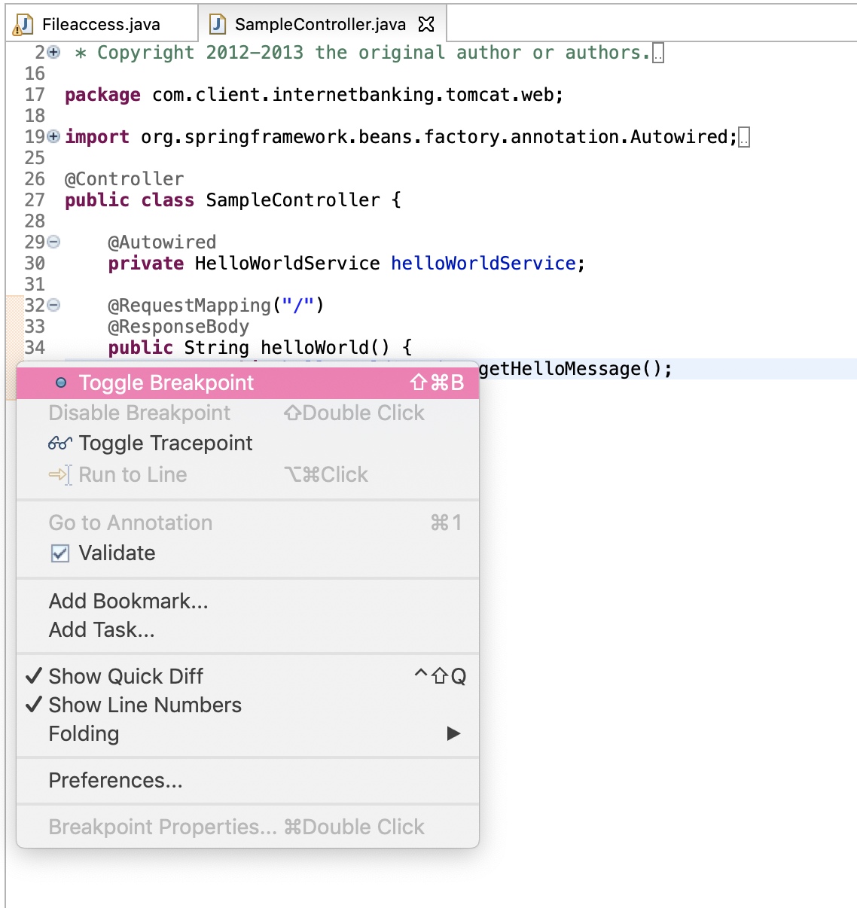

Place a break point on the lines where you want the compiler to pause the execution so that debugging of values in each variable can be done by the developer.

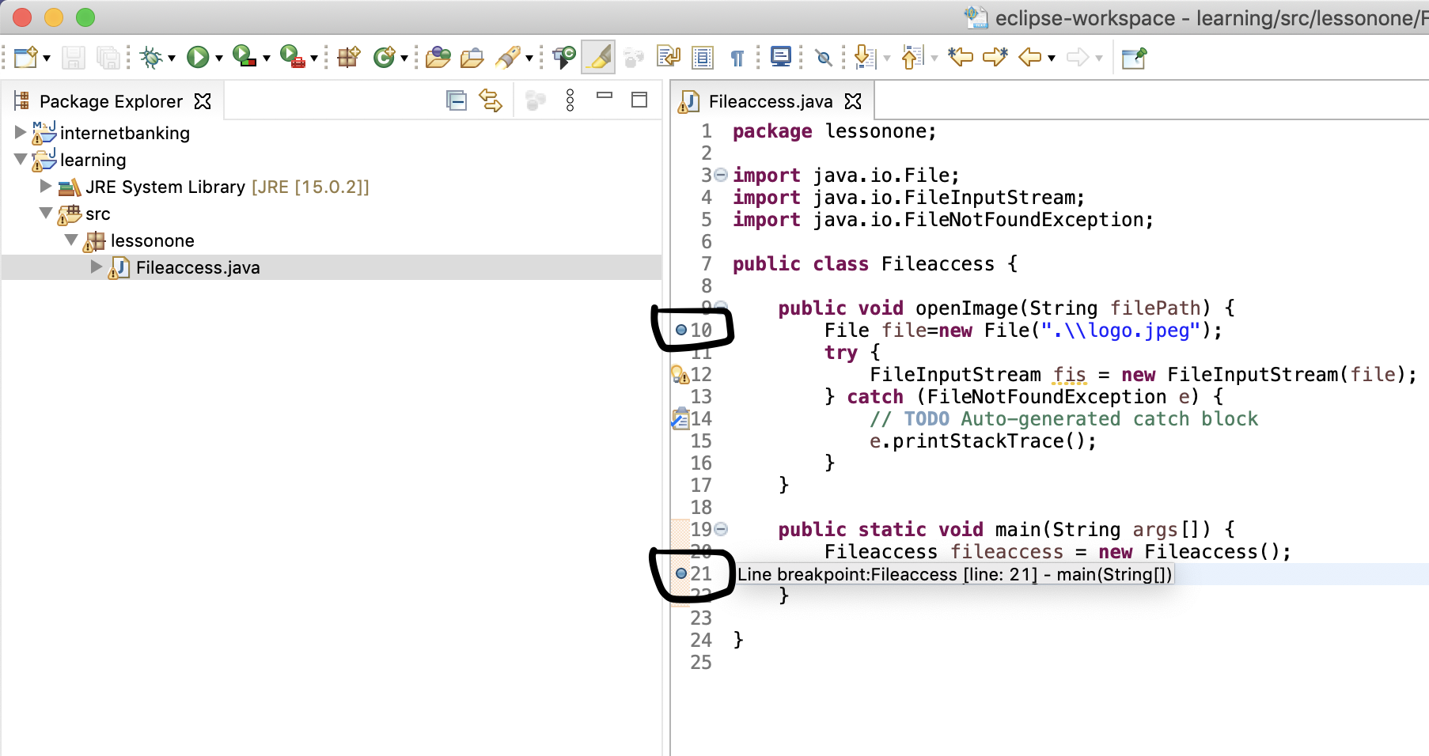

Accept to switch the perspective to “Debug”. Only here you can debug the code and not in any other perspectives.

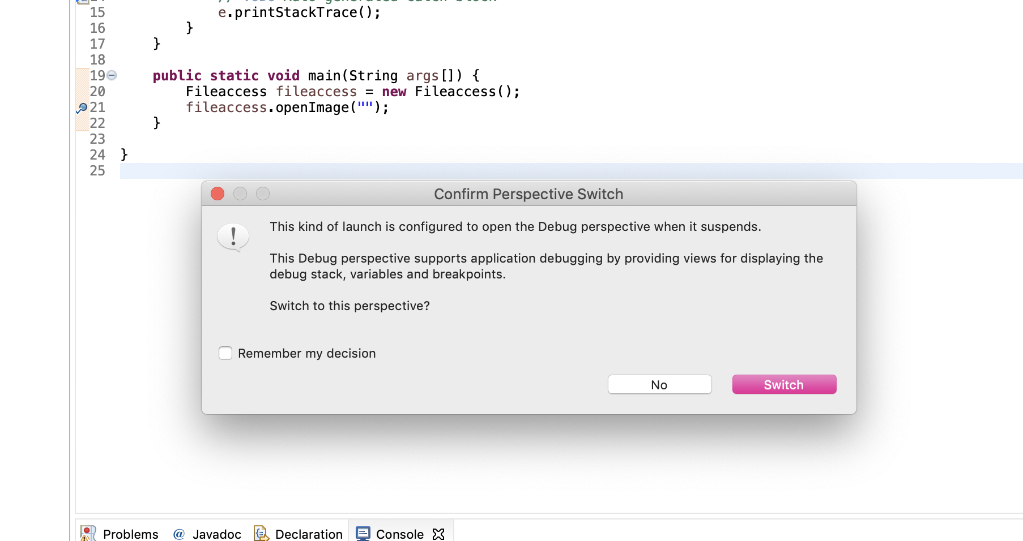

## 2.7 Debugging steps

When the execution comes to the line where debug point is placed, it will be highlighted with a green background.

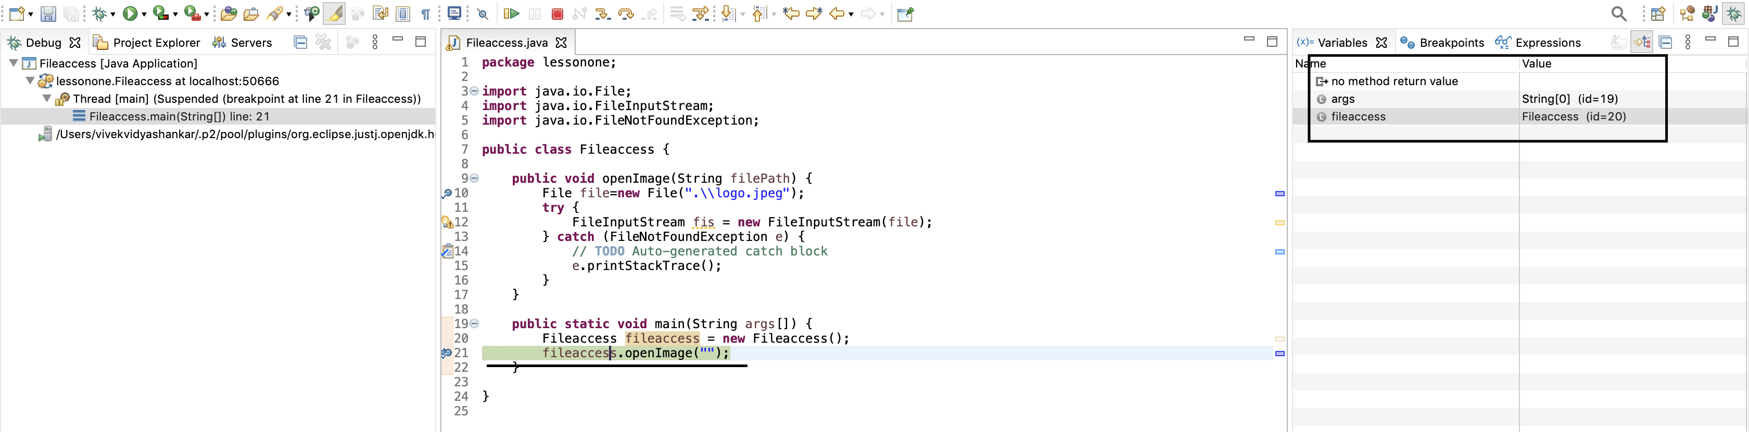

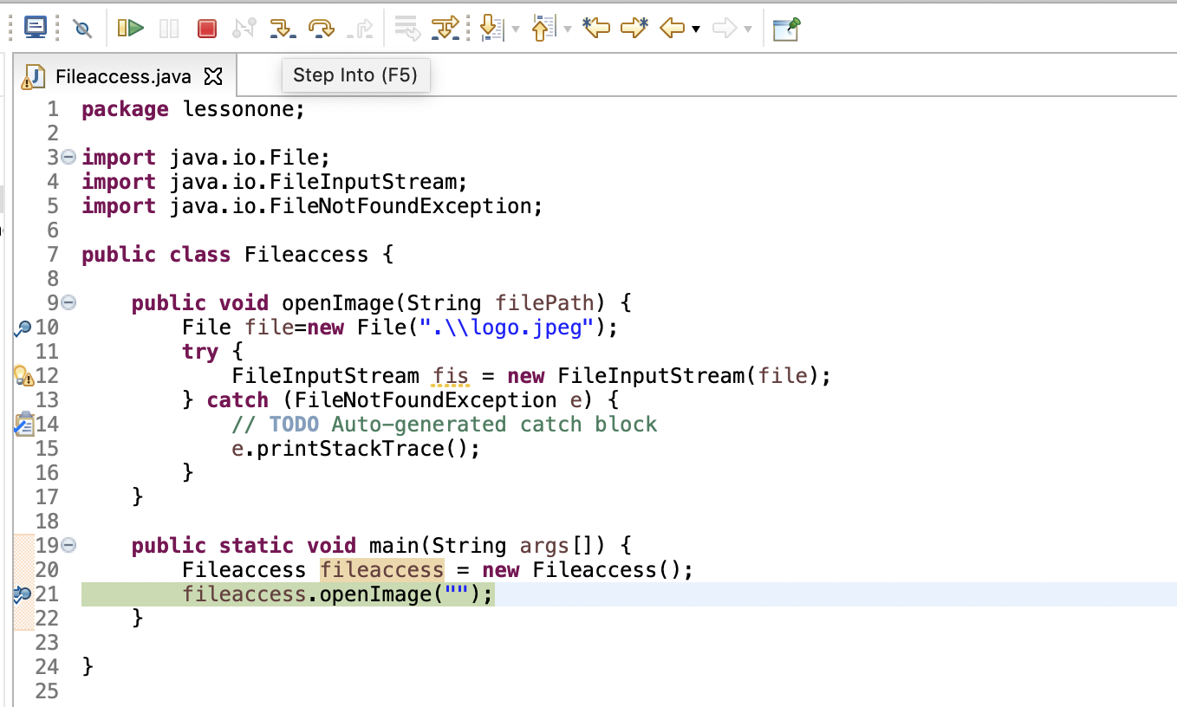

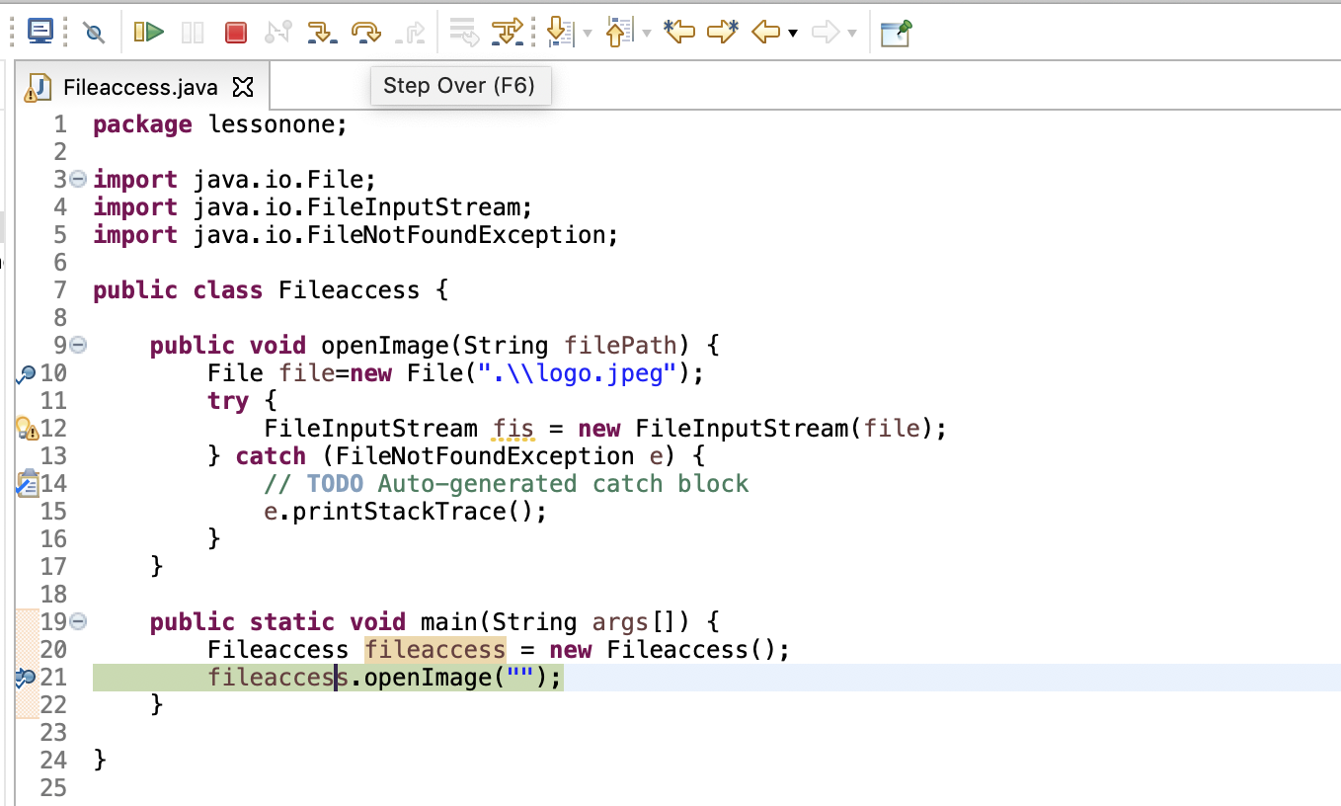

## 2.8 Variable modifications at run time debugging

At any given break point you can verify all the variables, not only the ones in the debugging line but remaining ones too.

In below example the Exception class “e” values are seen in the right side pane.

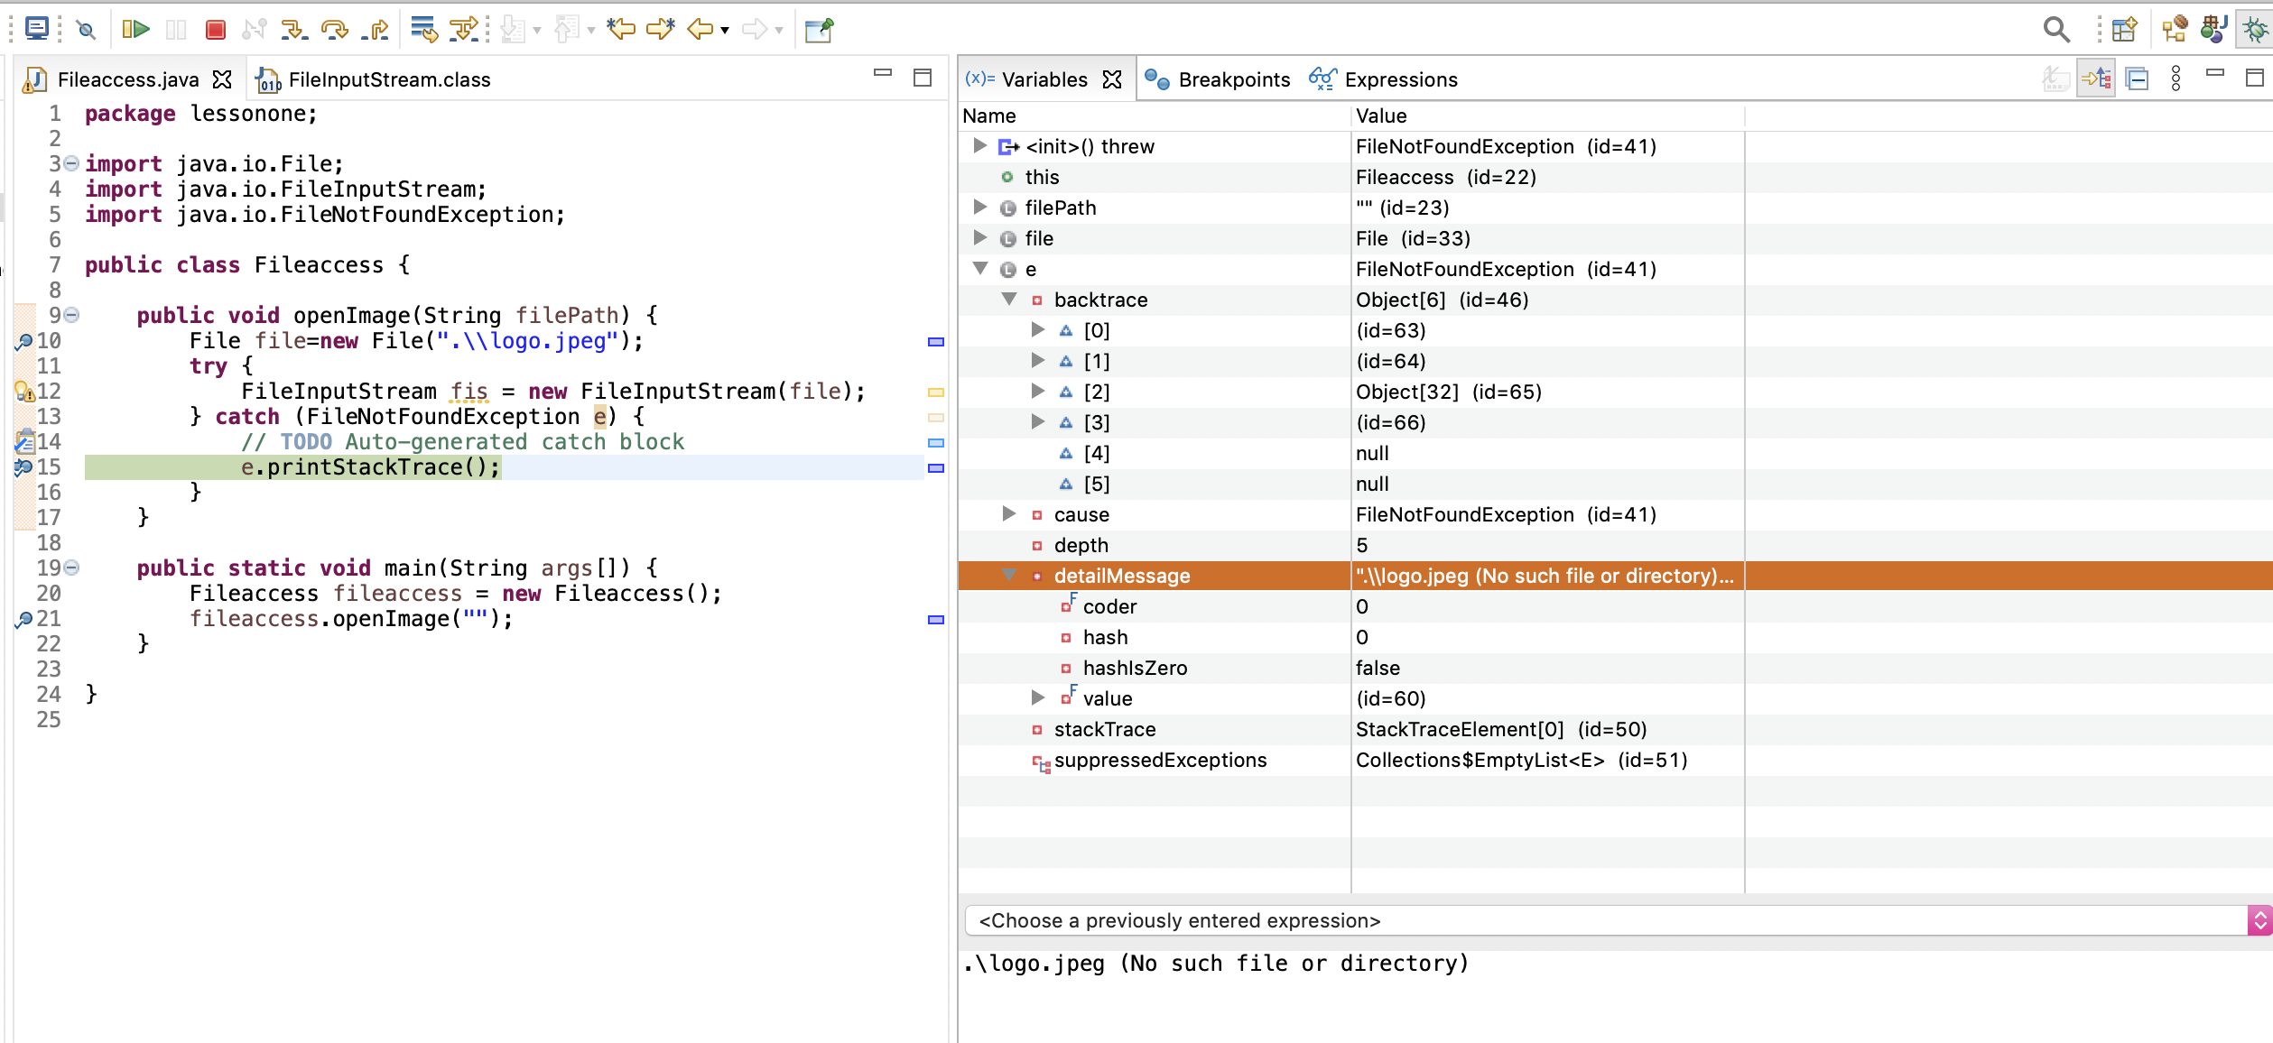

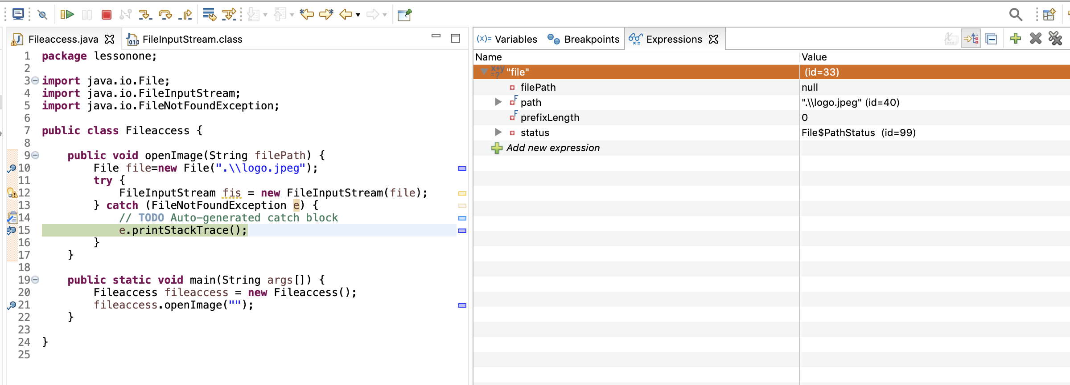

The values of the variable object at the debugging point can be modified, see the below example where the “detailMessage” value has been modified as “Modified text here with my own value”

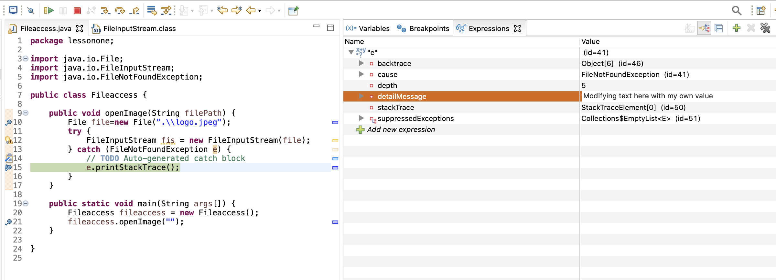

## 2.9 Viewing all Breakpoints and Keyboard shortcuts

All the break points applied in the project can be seen in the “BreakPoints’ tab.

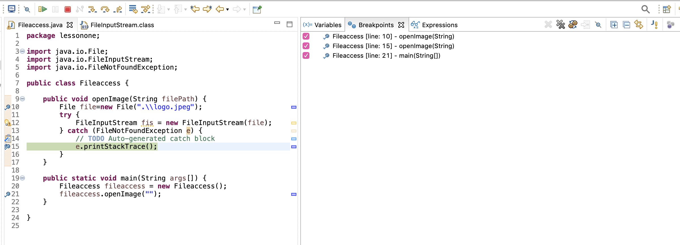

Below image provides key bord shortcuts which must be used to ease the work.

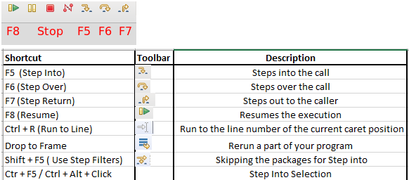

# Maven installation

Maven is an automation and management tool developed which enables developers to quote the jar file requirements(dependencies of your project) in a xml file called pom.xml.

Maven reads pom.xml file and downloads from central repository <https://repo1.maven.org/maven2/> where all our required jars are present. Screen shot 3 below gives an insight of how the repository is arranged.

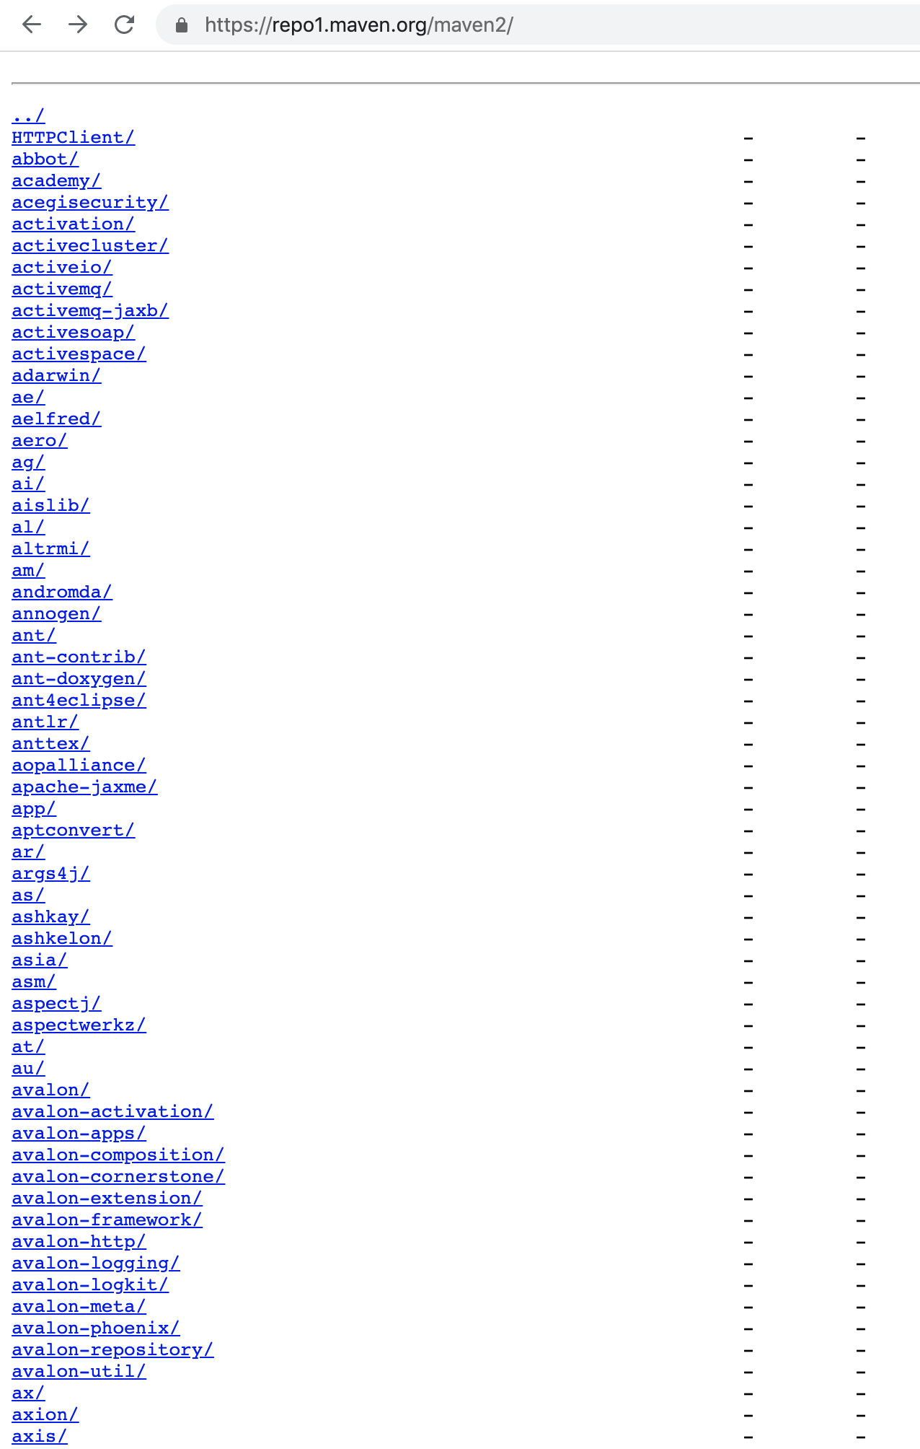

**Screen Shot 3:** Maven Repository

# Creating Spring Boot Project (API Development)

When a project is following / supposed to follow maven, choose maven project.

## 4.1 Maven project categories

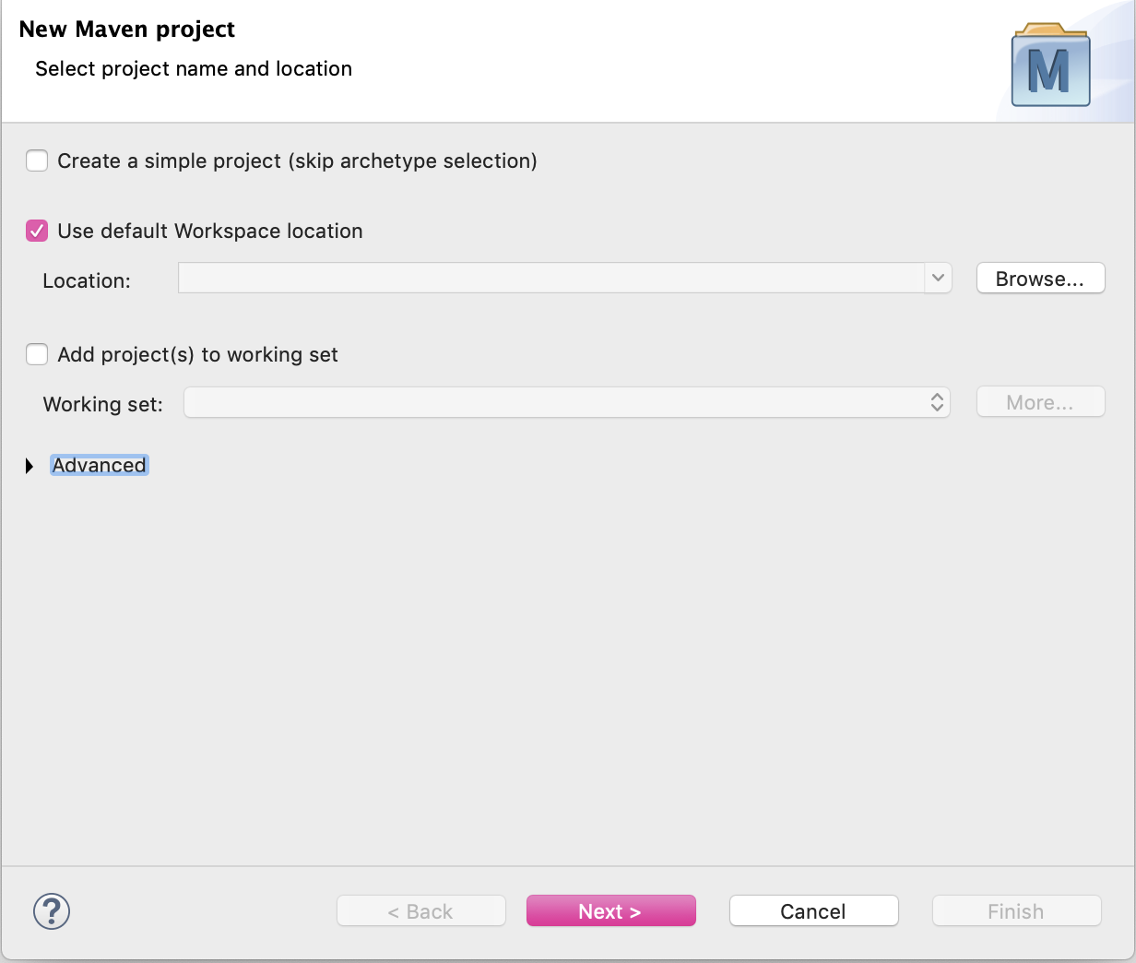

**Screen Shot 4:** Choose Maven Project

Under maven various options are present. If your project is SpringBoot then choose “spring-boot-blank-archetype” which is basic skeleton of this development.

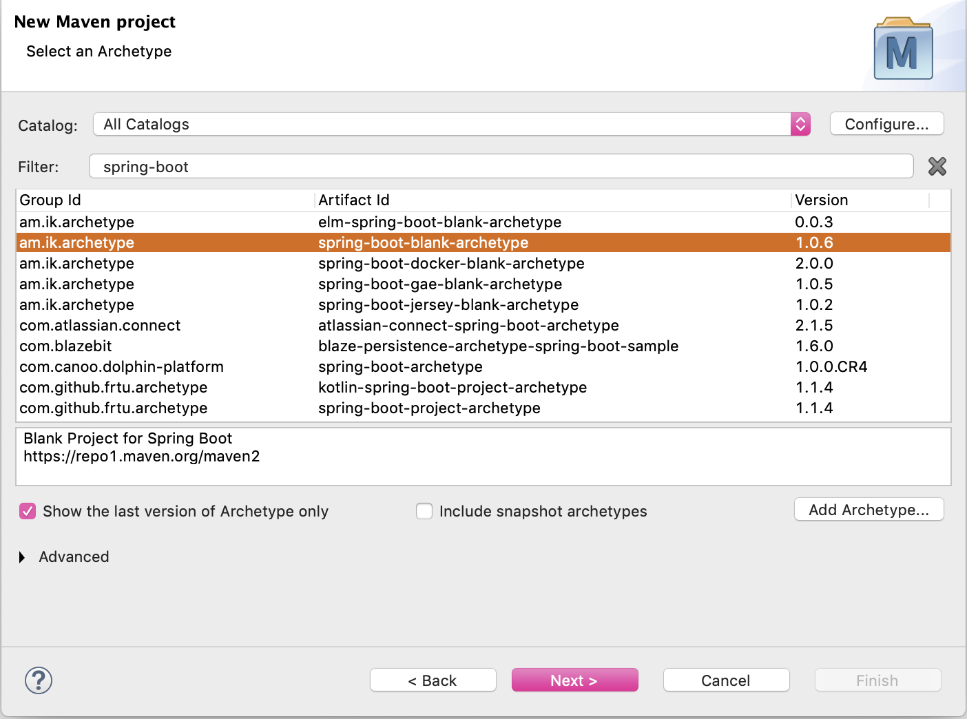

**Screen Shot 5:** Choose Maven Project

## 4.2 Group & Artifact id and Version

Choosing “**Group id**”, “**Artifact id**” and Version is important. This determines your class path base like for example “**com.client**.**internetbanking**”. Further classification can be based on needs of layers. Example: “**com.client**.**internetbanking.**controller”, “**com.client**.**internetbanking.**service”

Version will represent version number of the jar/war file. Every time a code changes are made before moving it to testing the version numbers must be increment.

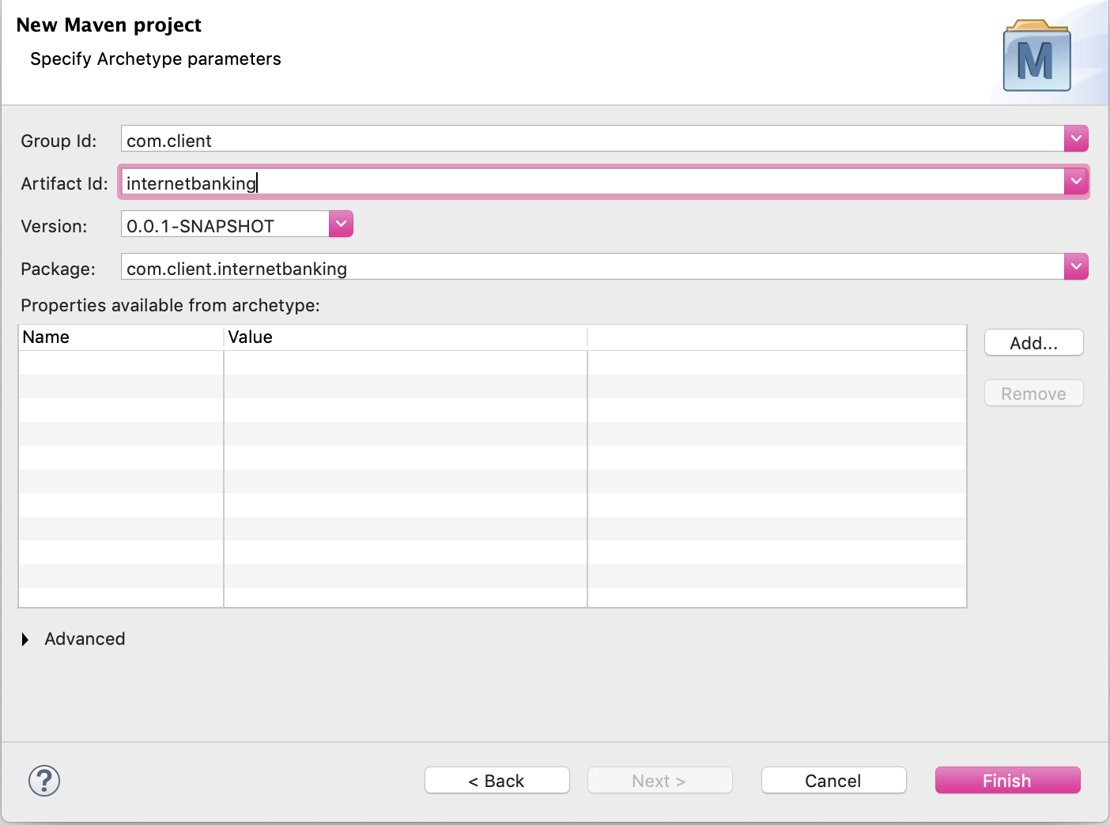

**Screen Shot 6:** Artifact ID

Immediately after clicking on **Finish** button build and compile starts, click on Progress tab and view the same(**Screen Shot 7** : Progress Tab).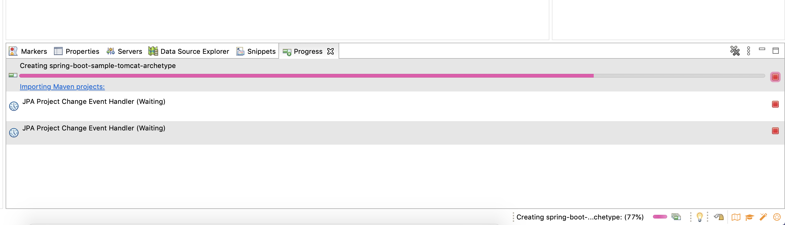

**Screen Shot 7:** Progress Tab

## 4.3 Project Build Path and .m2 repository

Right Click on the project and choose *Properties*. Choose *Java Build Path* and verify in Libraries tab whether the jars mentioned in pom.xml are downloaded to **C:\users\<your_userid>\.m2\repository**.

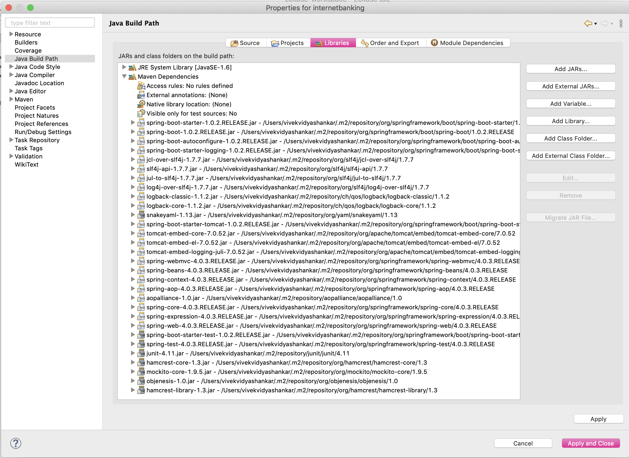

Under <dependencies> tag the jar files which were mentioned in {groupId, artifactId} will be created under **C:\users\<your_userid>\.m2\repository\**<groupId>**\**<artifactId>folder. Consider this example:

<dependency>

<groupId>**org.springframework.boot**</groupId>

<artifactId>**spring-boot-starter**</artifactId>

</dependency>

**C:\users\<your_userid>\.m2\repository\org\springframework\boot\spring-boot-starter.jar**

<groupId>org.springframework.boot</groupId> sub folders **org\springframework\boot** is created.

<artifactId>spring-boot-starter</artifactId> the jar file name will be created as **spring-boot-starter.jar**.

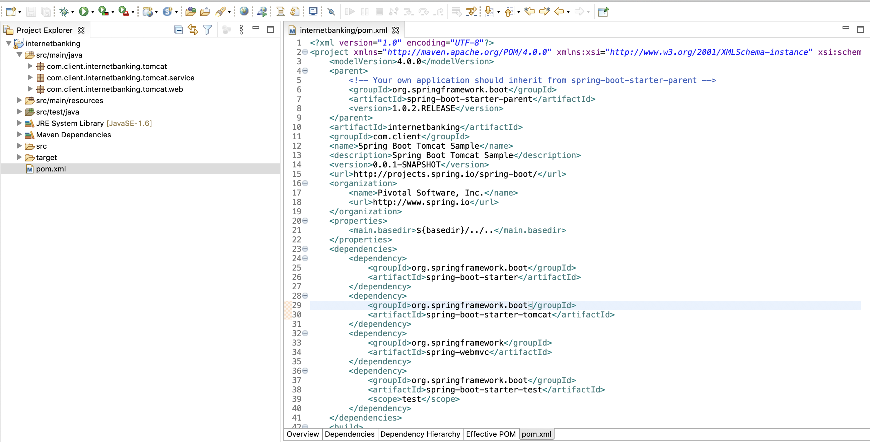

## 4.4 Maven Build steps

### 4.4.1 Maven Clean

Maven clean does clean of previous build generated in “target” folder.

Right click on the project.

Choose “Run As”.

Select “Maven clean”

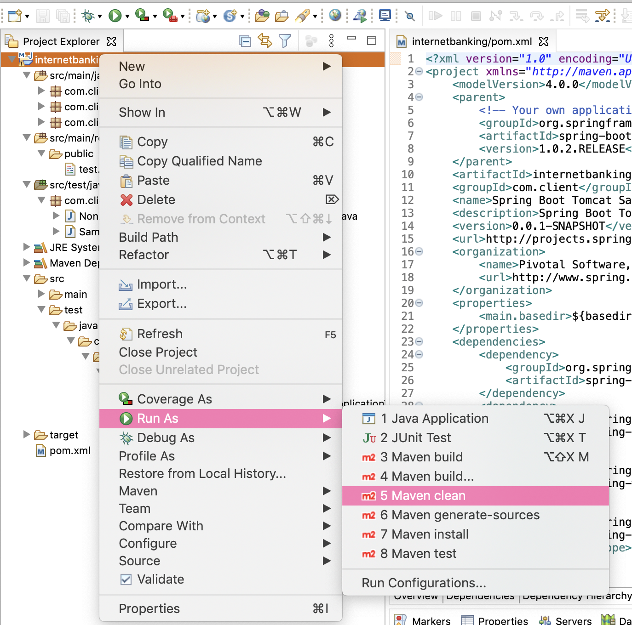

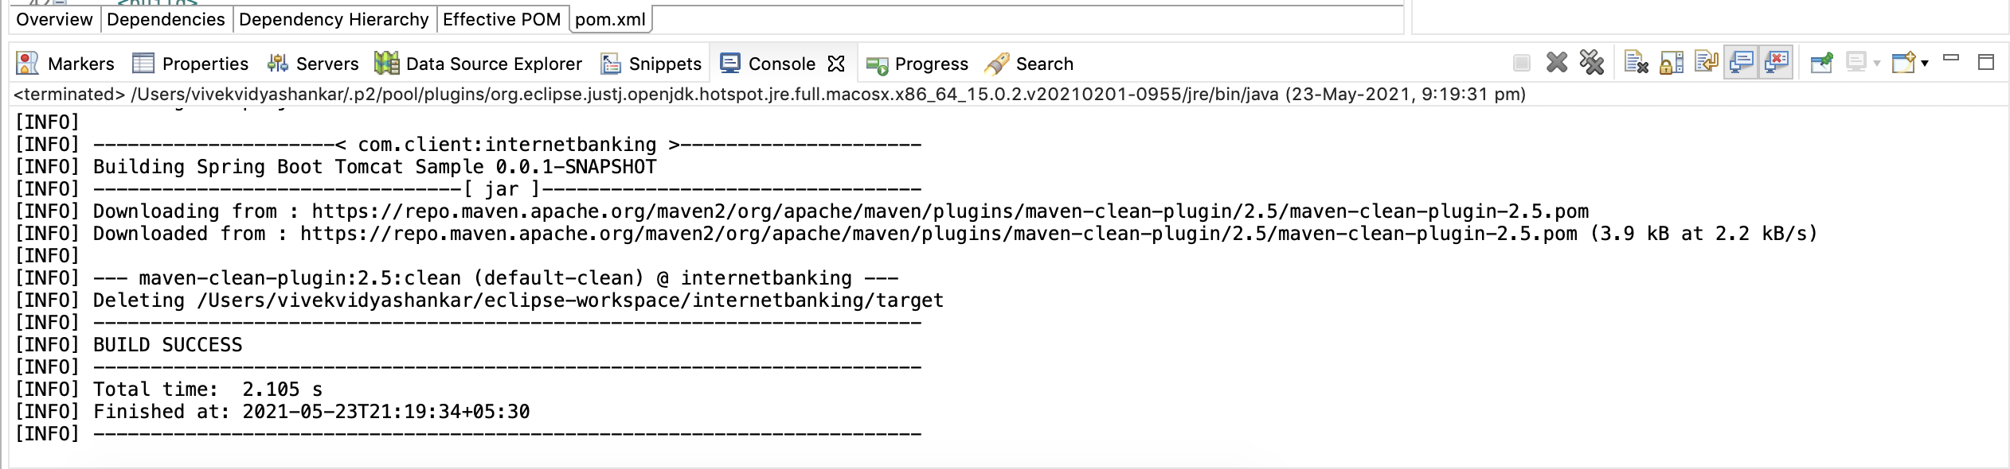

### 4.4.2 Maven Install

Right click on the project.

Choose “Run As”.

Select “Maven install”

Maven install does build and generates the jar file like <artifactId>.<version>.jar file.

<artifactId>**internetbanking**</artifactId>

<groupId>com.client</groupId>

<name>Spring Boot Tomcat Sample</name>

<description>Spring Boot Tomcat Sample</description>

<version>**0.0.1-SNAPSHOT**</version>

For the said entry we will see file generated as **internetbanking**.**0.0.1-SNAPSHOT.**jar

# 5. Maven build issues and debugging

## 5.1 Jars download issues

If maven build fails to download the jars mentioned in pom.xml then verify if **.m2** in folder is created in **C:\users\<your_userid>\**

Create a .m2 file and restart the maven build.

## 5.2 Folder .m2 deleted

If you’re working in the Virtual machines which are dynamically assigned and not a fixed one, there will be permission issues or maven build set up has to be done every day you login newly.

Create a .m2 folder and settings.xml and restart the maven build.

## 5.3 Jars download issues – Repository connect issues

If maven build fails to download the jars mentioned in pom.xml, **.m2** folder is created. Please check settings.xml for below values, the changes in credentials(user name, password), private key and permissions will have to be fixed by working with the right point of contact in project which will be CI/CD team typically.

<servers>

<server>

<id>server001</id>

<usernam>my_login</username>

<password>my_password</password>

<privateKey>${user.home}/.ssh/id_dsa</privateKey>

<passphrase>some_passphrase</passphrase>

<filePermissions>664</filePermissions>

<directoryPermissions>775</directoryPermissions>

<configuration></configuration>

</server>

</servers>

## 5.4 Jars download issues – Repository target issues

If maven build fails to download the jars mentioned in pom.xml, .m2 folder is created. Please check settings.xml for <repositories>, <pluginRepositories>.

Projects have the repositories combination of publicly available and in house(within the client’s project).

## 5.5 Build Failure – Project Maven update

If maven build fails without clear pointer to above points then Project update through maven, to get pom.xml latest. This happens when changes to pom.xml has happened by various team members.

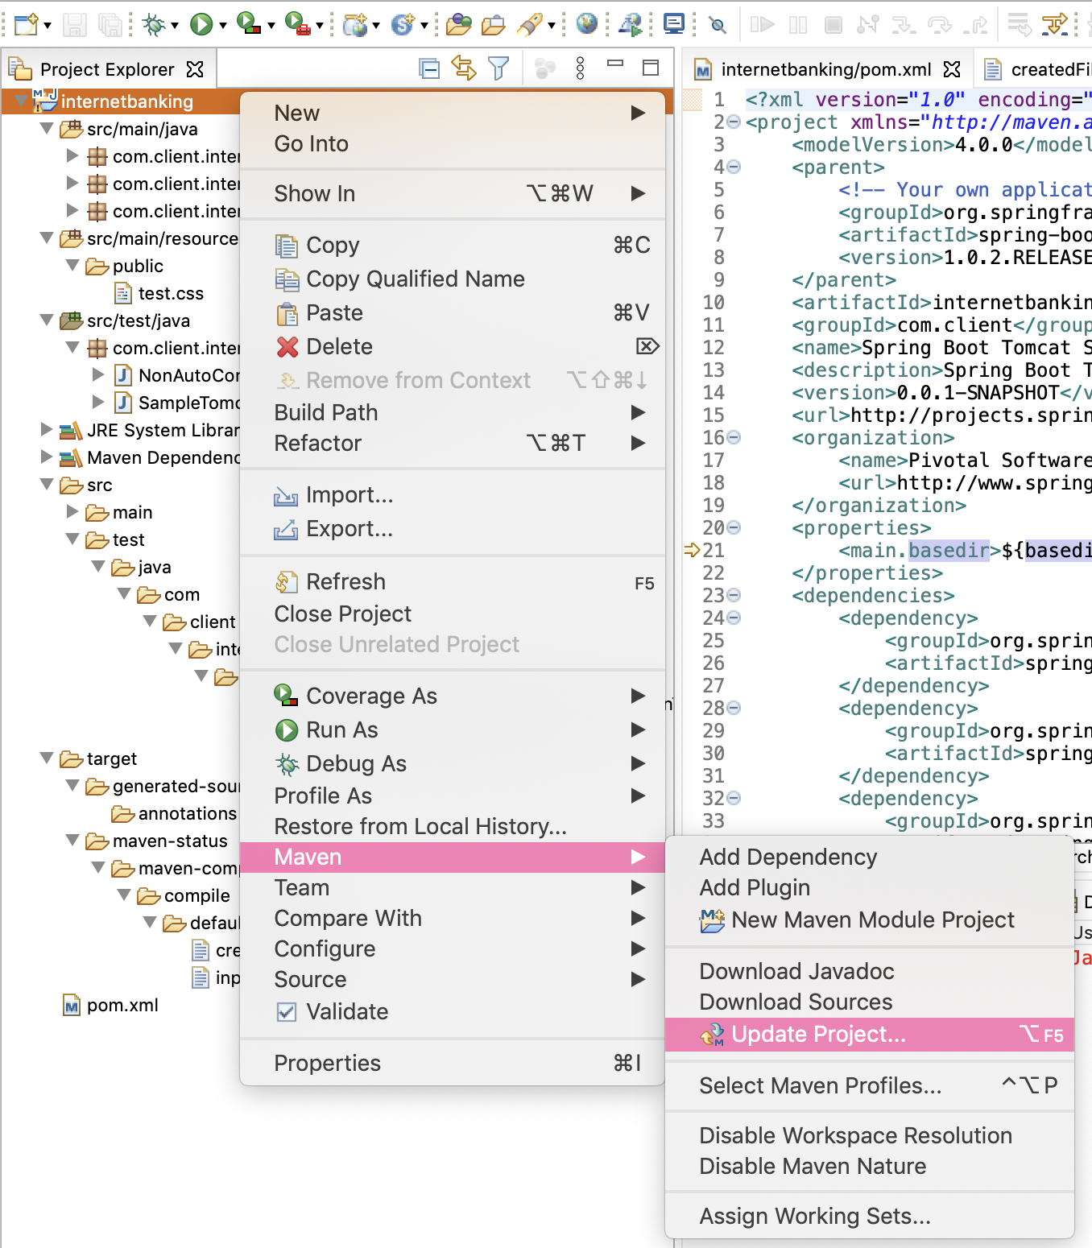

Resource full article on this : <https://medium.com/javarevisited/8-commands-that-help-to-resolve-maven-dependency-problems-fc56676bc647>

# 6. Running Spring Boot Application

## 6.1 Starting spring boot application

Run As a Maven build and in goals give “spring-boot:run”

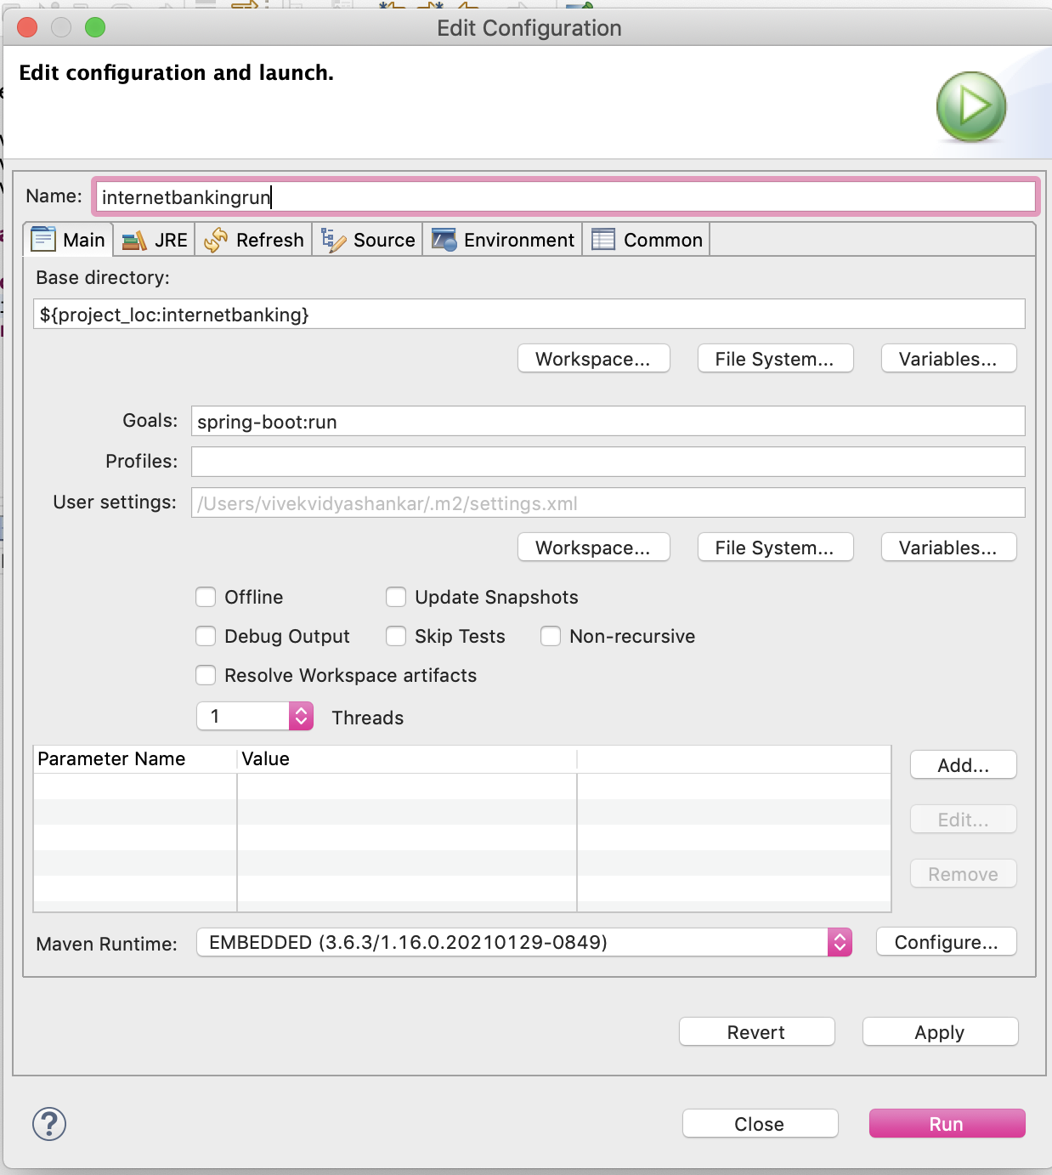

## 6.2 Starting spring boot application in Debug mode.

To debug a application “Debug As” a Maven build and in goals give “spring-boot:run”

Tomcat will be running and ready.

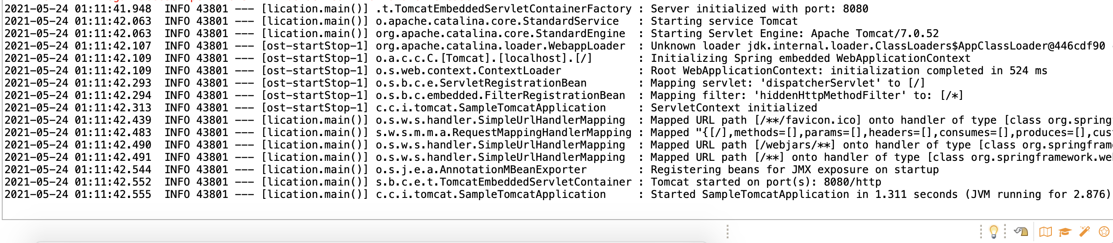

# 7. Debug Spring Boot Application

To debug a request coming from the client who is requesting the service, add the breakpoint on the line number using double click on the line number.

At the point where break point is applied, we can examine the variables, its values. We can evaluate what is wrong at every object and variable level to fix the issues being fixed in the project work.

**Note** the left side in debug explorer which shows the trace of the calls from where the code execution has started and arrived at where our break point is placed.

This track trace will be need to be looked at to understand if the order of classes which are being called is as per our design.

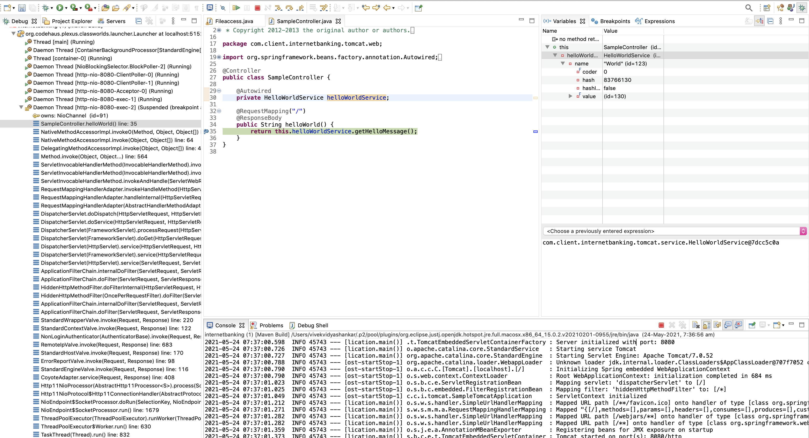

## 7.1 API targets request giving 404

The @Controller annotation is assigned on the Controller objects. Verify in which controller class the **@RequestMapping** assigned at class level and method levels both.

In below example the URL request is [https://myserver.com**/home/start**](https://myserver.com/home/start)

### 7..1.1 URL mismatch

If the URL requested is [https://myserver.com**/homenew/start**](https://myserver.com/homenew/start) there will be no matching controller and method to process the request will be found and 404 error will be thrown.

@Controller

@RequestMapping("/home")

**public** **class** SampleController {

@Autowired

**private** HelloWorldService helloWorldService;

@RequestMapping("/start")

@ResponseBody

**public** String helloWorld() {

**return** **this**.helloWorldService.getHelloMessage();

}

}

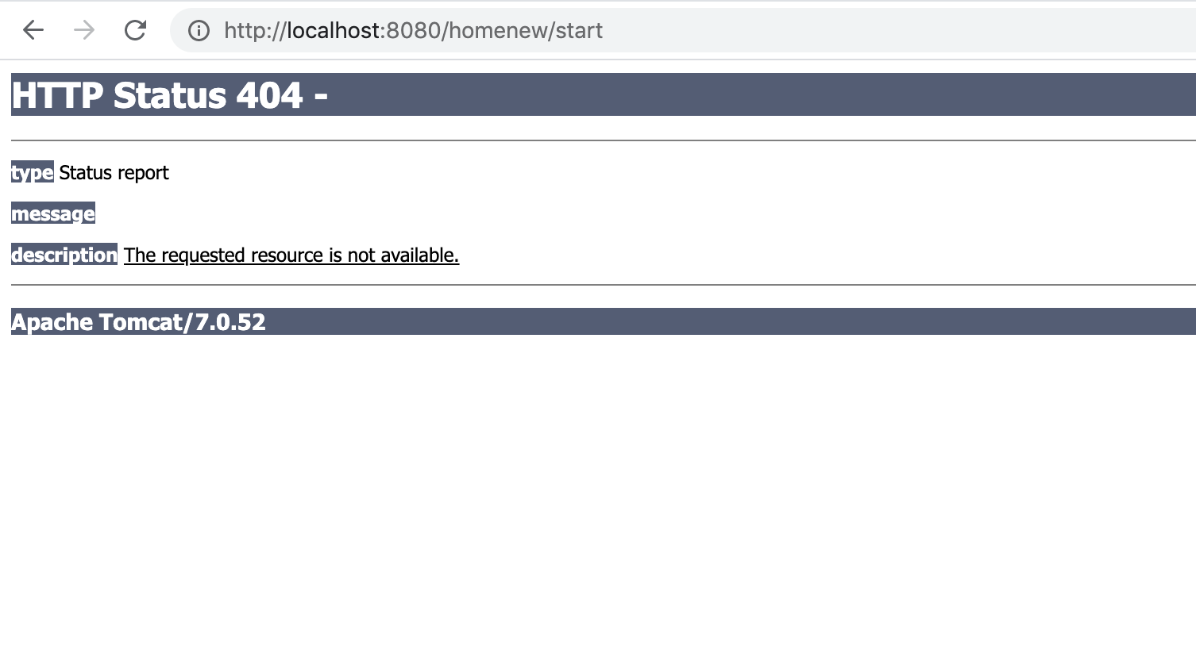

## 7.2 Annotations missing

When a 404 error is shown due to unmapped URL, verify if the method has @RequestMapping and correct URL mentioned.

@Controller

@RequestMapping("/home")

**public** **class** SampleController {

@Autowired

**private** HelloWorldService helloWorldService;

@ResponseBody

**public** String helloWorld() {

**return** **this**.helloWorldService.getHelloMessage();

}

}

## 7.3 API targets request giving 405

Services have GET, POST, PUT, DELETE methods. If a API is configured for POST and requestor has given GET request (or any such mismatch) 405 error is thrown.

Requestor will need to be informed about the correct method to access to fix this.

Note that if a GET (Typically fetches values from DB and sends across) is configured as POST/PUT, then it will be a design issue and API design must be fixed.

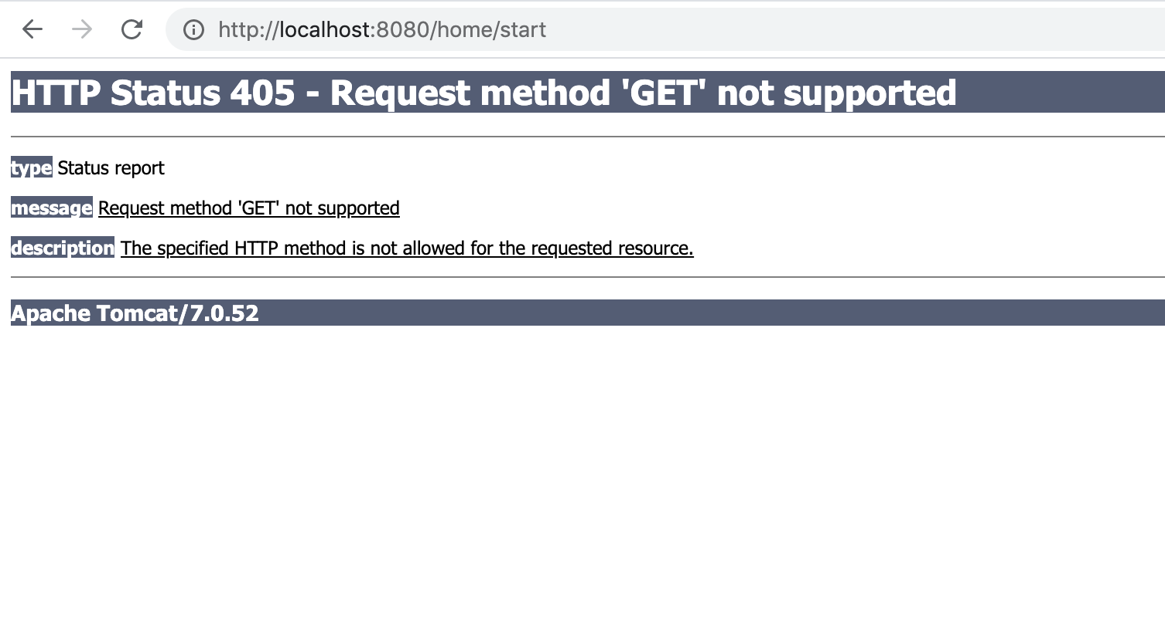

@Controller

@RequestMapping("/home")

**public** **class** SampleController {

@Autowired

**private** HelloWorldService helloWorldService;

@RequestMapping(value="/start", method=RequestMethod.***POST***)

**public** String helloWorld() {

**return** **this**.helloWorldService.getHelloMessage();

}

}

## 7.4 API targets request giving 500 error

When a API is giving 500 Internal Server Error, this indicates that code run has encountered serious exception and exception handling is missing.

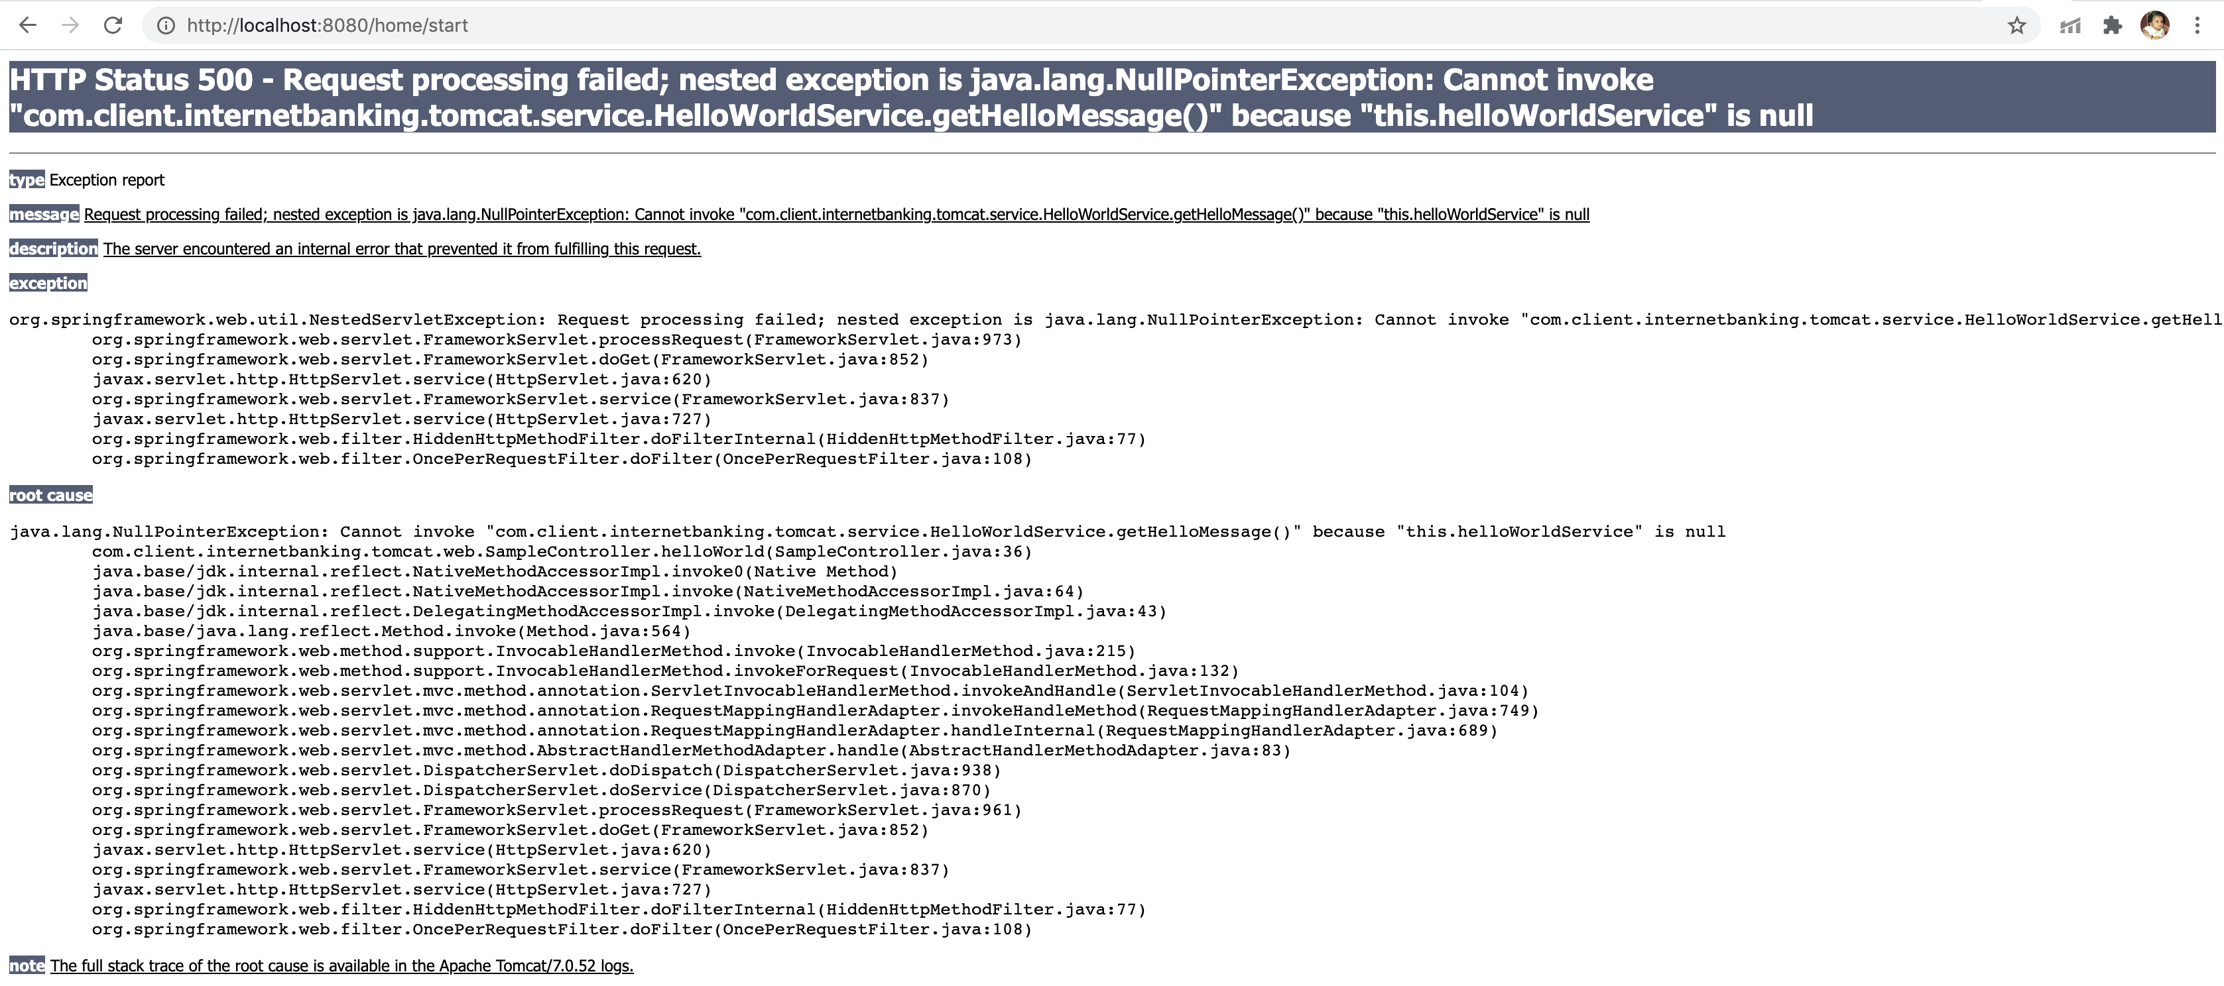

## 7.5 API targets request giving 503 error

When a API is giving 503 Internal Server Error, this indicates that code is waiting on some other resource, typically in a project the API’s will be waiting for DB or other API calls to return, but delay on the same leads to 503 issue reported.

1. Please check if DB query / Stored Proc called is in waiting mode.
2. Please check on the server the RAM, CPU Utilization which will be causing capacity issues.
3. Please check if server is unable to take additional load and our requests are being not processed.

In any of the above scenarios reporting and working with the concerned team immediately is needed. Such errors must not happen in production as it will be considered as service down time.

## 7.6 Dependency Injection issues

### 7.6.1 Auto-Wire issues

Spring Boot application follows “Auto-wired” style of Dependency injection using @Autowired annotation

When a API is giving 500 Internal Server Error, verify in the log files for NullPointer exceptions to pin point which object injection hasn’t happened.

In the below example @Autowired is not applied on helloWorldService and calling getHelloMessage is throwing Null Pointer.

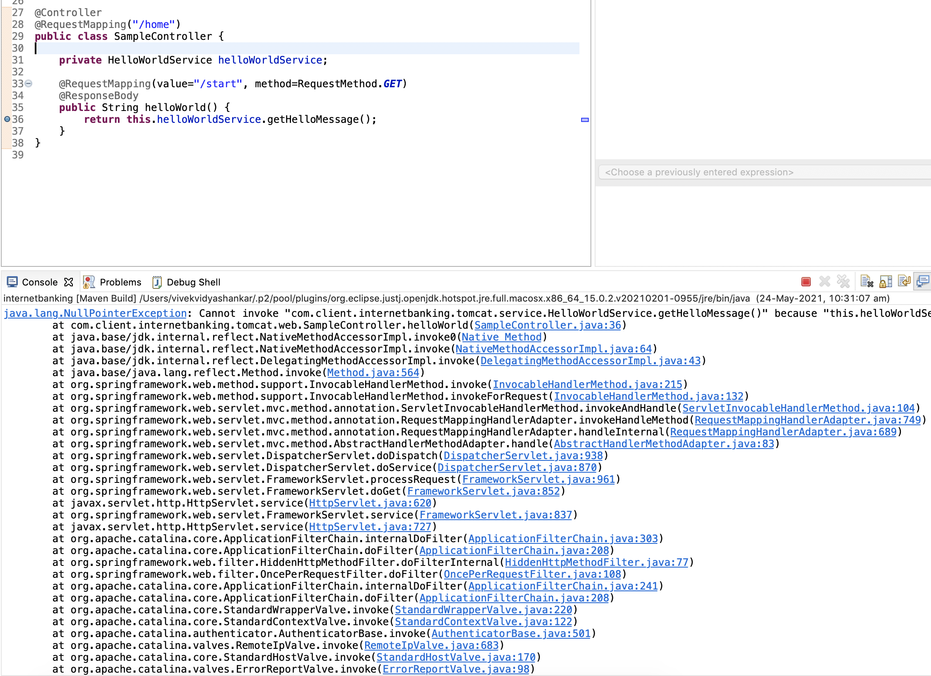

### 7.6.2 Auto-Wire issues with duplicate URL mapping

When the same URL mapping is provided to two different methods in any bean, the server start itself will be throwing issues.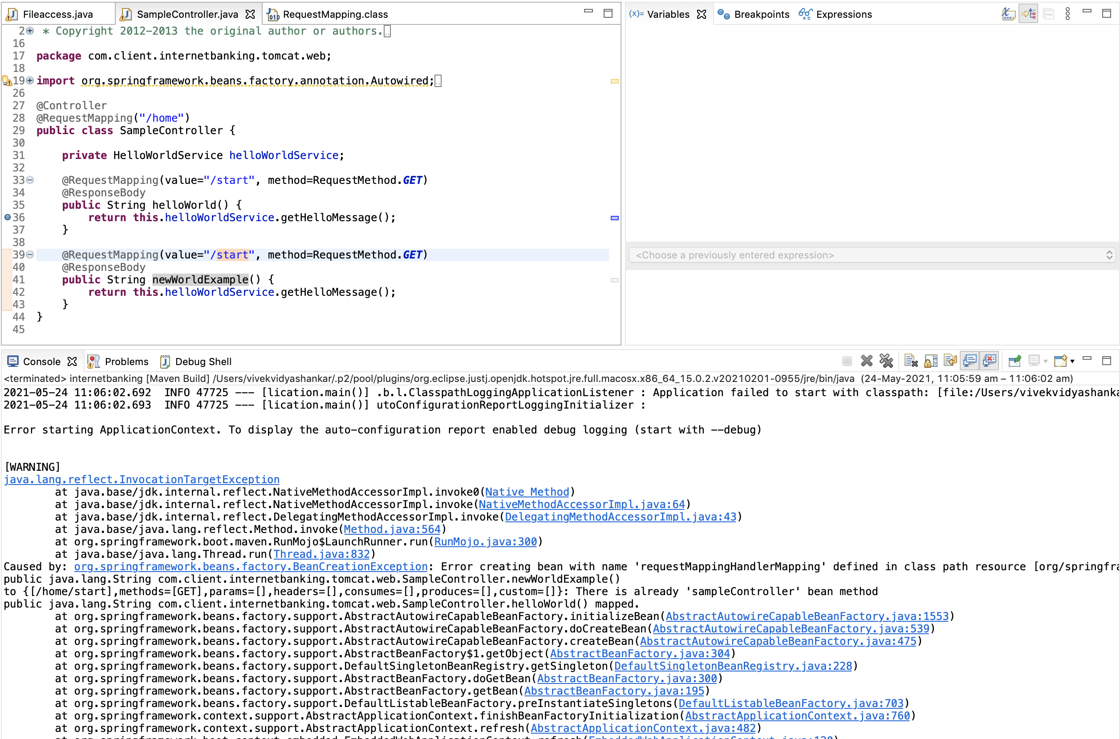



## 7.7 Data saving issues

A API is successfully executed and returned the response but the consumer is reporting issue that he is not able to view the data as per the latest changes.

1. Verify DB queries of the API which saved the values to DB.
2. Verify DB queries of the API which is fetching the new values.
3. Reach out to DBA’s if you see no query issues and data sync up in the distributed DB is not happening.

# 8. Creating a spring batch project and running it

Spring batch typically follows the sequence of reading data, processing it and writing it. For example, reading a text file from a folder path and converting it into xml.

## 8.1 Creating a project and configuring it for batch

The project creation can follow the same as that of spring boot as in section 4 to create a spring batch project. In addition to that the below configuration is required for spring batch application

Below is the spring batch configuration file.

@Configuration

@EnableBatchProcessing

**public** **class** **BatchConfiguration** {

@Autowired

**public** JobBuilderFactory jobBuilderFactory;

@Autowired

**public** StepBuilderFactory stepBuilderFactory;

@Value("${file.input}")

**private** String fileInput;

}

This spring batch configuration file has to be registered in context of the main class where we have declared the @SpringBootApplication (the class will get created when we create the spring boot project). The context registration can be done in the main class as below.

AnnotationConfigurationApplicationContext context=new AnnotationConfigurationApplicationContext();

Context.register(**BatchConfiguration.class**);

@Bean

**public** Job **importUserJob**(JobCompletionNotificationListener listener, Step step1){

**return** jobBuilderFactory.get("importUserJob") .incrementer(**new** RunIdIncrementer()) .listener(listener) .flow(step1) .end() .build();

}

@Bean

**public** Step **step1**(JdbcBatchItemWriter writer) {

**return** stepBuilderFactory.get("step1") .<Coffee, Coffee> chunk(10) .reader(reader()) .processor(processor()) .writer(writer) .build();

}

The corresponding methods for reader, writer and processor can be declared.

## 8.2 Running a spring batch Application

To run a spring boot application the job name has to be given in the program arguments of run configuration.

Perform the below in the main class

RightClick🡪Runas🡪Run Configuration🡪Arguments tab🡪programArguments🡪 (specify a spring batch name)

Eg. MyFirstbatchProject

Note:

This batch job will be run run through the script file where we can configure the job name and place it with a time scheduler where a specific job has to be done at a periodic interval of time.

For example : salary processing for the employees of the company. Here the salary settlement has to be performed on a monthly basis hence the scheduler can be given monthly. Let us go through the basic spring batch application and then can go into the script file configuration.

## 8.3 Debugging a spring batch Application

When you run as java application from the main place the debug point where required and run debug the application. Here we can verify the value of the variables and change the variable values as required.

Below is the exception which we will get when the batch config annotation is missing.

**NoSuchBeanDefinitionException**

To debug a request coming from the client who is requesting the service, add the breakpoint on the line number using double click on the line number.

At the point where break point is applied, we can examine the variables, its values. We can evaluate what is wrong at every object and variable level to fix the issues being fixed in the project work.

The exception will be thrown when the annotation @EnableBatchProcessing is missing from the configuration. Make sure that this annotation is present.

The exception will be thrown when the configuration class is not registered in the context. Make sure that the context is registered.

# 9. Spring Tool Suite

Spring Tool Suite is custom made Eclipse version for Spring related projects.

The steps for creating project is similar and screen shots below detail the same. Please use the category “Spring Boot” options here.

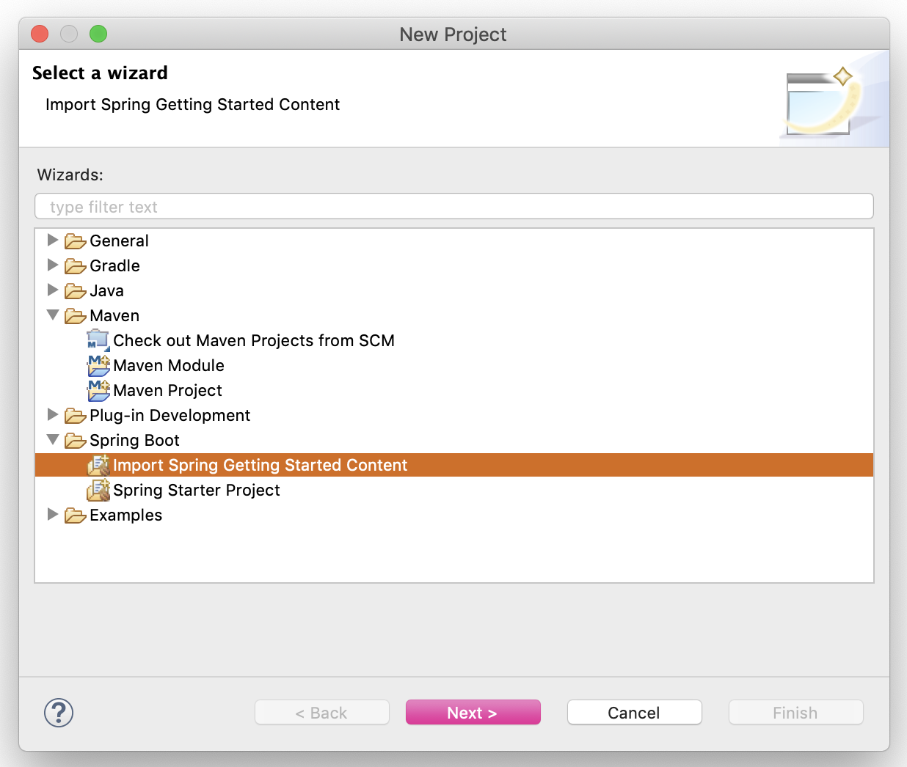

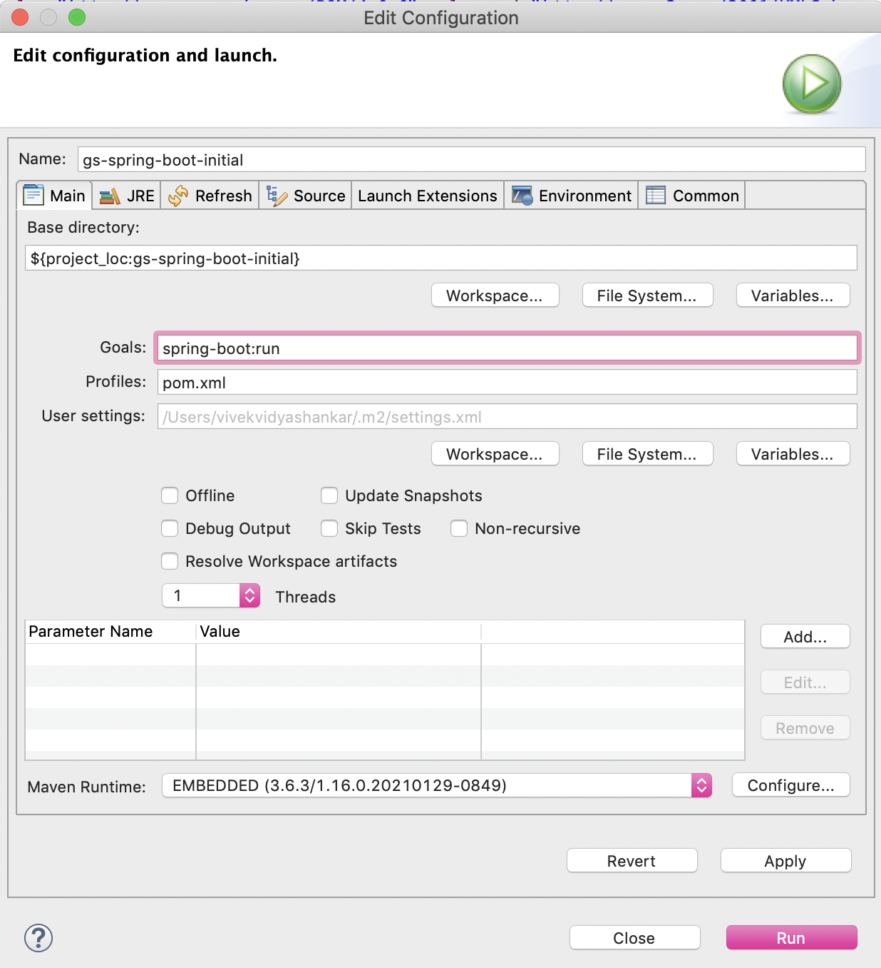

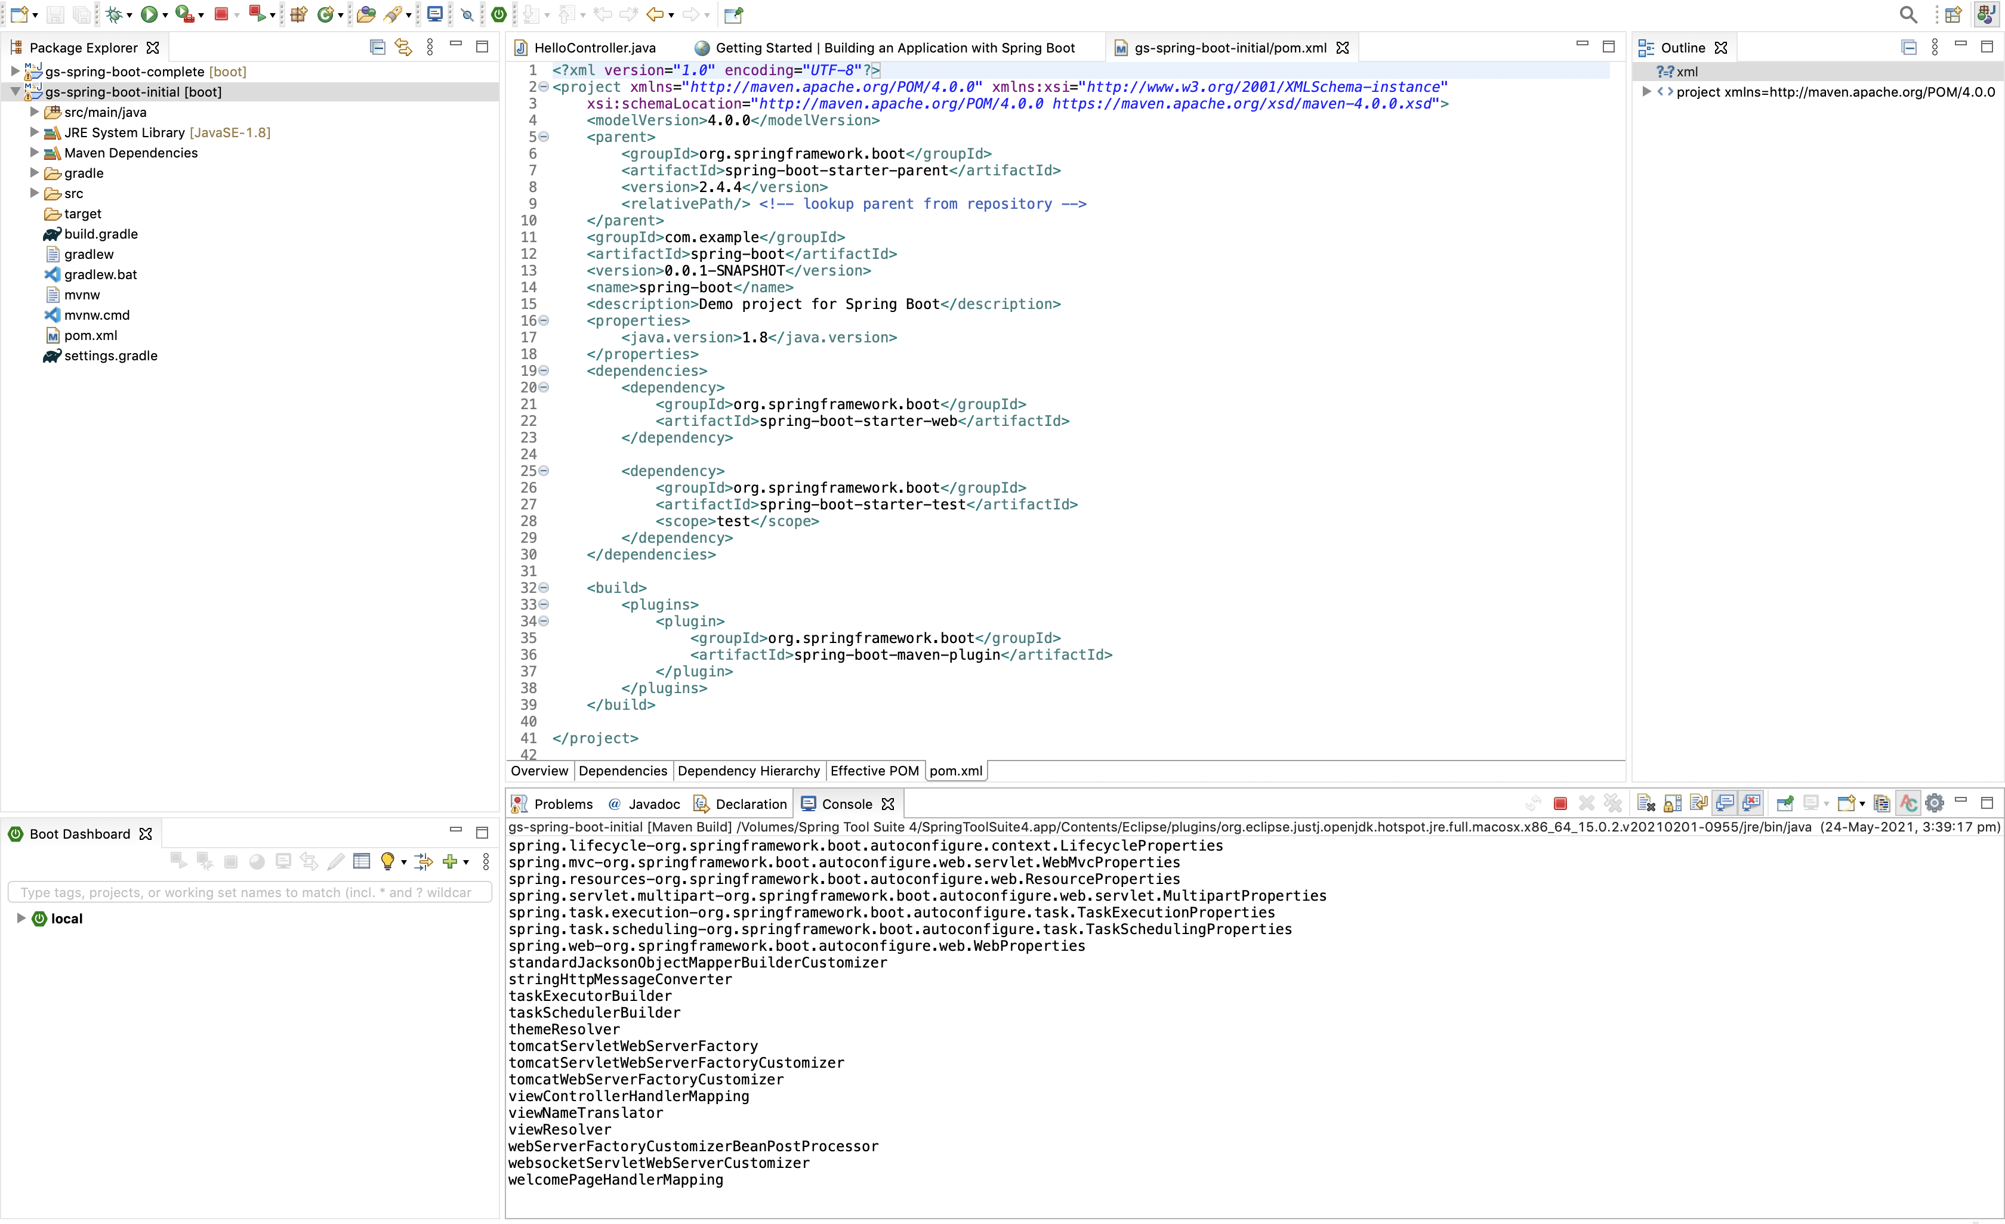

# 10. Code with bug for fixes.

The code “internetbanking.zip” has a spring boot project which has errors to be fixed for the 1. Errors which will lead to Tomcat server start

2. URL mismatch leading to 404, 405.

3. Duplicate use of URL’s across the controllers.

4. Auto-wiring missing leading to HTTP 500 series exceptions.

Use this project code in Eclipse / Spring Tool Suite and fix the same as per the debugging detailed discussed in various sections above.